YEAR 7 MATHEMATICS SCHEME OF WORK 2020
PROCESS STRAND - PROBLEM SOLVING
Formulating | - Identify the information needed to solve a problem, classifying and sorting it where necessary.  - Represent problems mathematically, making appropriate use of diagrams, words, symbols, tables and graphs.  - Use and apply mathematical knowledge, methods and techniques across different mathematical domains, including solving problems in unfamiliar contexts.  Break a complex calculation into simpler steps, choosing and using appropriate and efficient operations, methods and resources.
Analysing & reasoning | - Use appropriate mathematical techniques and notation to explain how to solve a problem.  - Check calculations, methods and mathematical arguments.  - Extend the answer to a problem to a wider context by generalising.  Extend problems by asking ‘What if...?’ and altering some of the original variables or constraints.
Interpreting & justifying | - Decide whether an answer is reasonable.  - Interpret answers referring to the context of the original problem.  - Justify answers and conclusions, orally and in writing.  - Explore whether statements are always true, sometimes true or never true.  - Recognise that some statements or conclusions maybe misleading or uncertain.  Understand the importance of a counter-example in disproving something is always true.

- NUMBERS, OPERATIONS & ALGEBRA (21 WEEKS)
SUB-TOPICS | LEARNING OUTCOMES | LEARNING EXPERIENCE/EXEMPLIFICATION | INSTRUCTION TIME
1.1 PROPERTIES OF NUMBERS | Students should be able to: |  | 2
1.1.1 Multiples, Factors, Common Factors, LCM, HCF, Primes, Test of Divisibility, Index Notation, Prime Factors, Squares & Square Root, Cubes & Cube Root | - Recognise and use multiples, factors, common factors, lowest common multiples, highest common factors, primes (less than 100) and tests of divisibility when solving problems.  - Understand, read and write index (exponent, power) notation for a^{n} where n is a positive integer.  Understand, read and write index notation for positive integer powers of 10.  - Express 2-digit whole numbers as prime factors.  - Understand square numbers and positive square roots of positive integers and recognise patterns in their sequence.  - Understand cube numbers and cube roots of positive integers and recognise patterns in their sequence. | - Find factors and multiples of a given number.  - Understand the relationship between multiples and factors.  Examples :  - What are the factors of 12?  1 x12 = 12  2 x 6 = 12  3 x 4 = 12  1, 2, 3, 4, 6 and 12 are the factors of 12.  Correspondingly, 12 is a multiple of 1, 2, 3, 4, 6 and 12.  - List down the first three multiples of 6?  1 x 6 = 6  2 x 6 =12  3 x 6 = 18  The first three multiples of 6 are 6, 12 and 18.  Correspondingly,  1 and 6 are factors of 6;  2 and 6 are factors of 12;  3 and 6 are factors of 18.  - List down the first four multiples of 7.  - What are the common factors of 20 and 30?  - List down the first two common multiples of 2 and 3.  - Find lowest common multiples (LCM) and highest common factors (HCF) of a given number.  - Solve word problems involving LCM and HCF.  Examples:  - Rafa has 45 cookies. She wants to pack an equal number of cookies into different bags. In how many ways can she pack the cookies if she must use at least two bags?  - Three bus services (A, B and C) leave the bus station together at 9.00 a.m. Service A leaves the station every 10 minutes, Service B leaves the station every 15 minutes and Service C every 25 minutes. At what time will the 3 services next leave the station together?  - A choir at your school wants to divide the choir into smaller groups. There are 24 sopranos, 60 altos and 36 tenors. Each group will have the same number of each type of voice.  - What is the greatest number of groups that can be formed?  - How many sopranos, altos and tenors will be in each group?  - Three bus services (A, B and C) leave the bus station together at 9.00 a.m. Service A leaves the station every 10 minutes, Service B leaves the station every 15 minutes and Service C every 25 minutes. At what time will the 3 services next leave the station together?  - The LCM of two numbers is 60. One of the numbers is 12. Find the other number. Find as many answers as you can.  - Recall prime numbers (less than 100).  Examples:  - Is 5 a prime number? Explain your answer.  - Is 80 a prime or composite? Explain your answer.  - Solve problems involving divisibility rules.  Examples:  - Is 72 divisible by 2?  - Is 53 divisible by 3?  - Is 180 is divisible by 2, 3, 4, 5, 9 and 10?  - Read and write index notation for $a^{n}$ where n is a positive integer and for positive integer powers of 10.  base  index  $a^{n}$  - Emphasize index = exponent = power.  Examples:  - Find the missing base.  _____³ = 27  - Write down the expression in index form.  $41 ∙41 ∙70 ∙70 ∙70$  $=41$____ $∙70$ ___  - Fill in the missing exponent (power / index).  $10$ ____ $=10,000$  - Express 2-digit whole numbers as prime factors.  Example: List down 5 numbers which has only two prime factors 3 and 5.  - Write the prime factorisation of a given number in terms of index notation.  Example:  Express 72 as prime factors. Leave your answer in index notation.  - Review squares and square roots.  Examples: Calculate mentally:  - $4^{2}+9$  - ${(4+3)}^{2}$  - $5^{2}-7$  - $\sqrt{9+7)}$  - $\sqrt{(40-2^{2})}$  - What is the fourth square number?  - Relate squares and square roots with Area and Perimeter of Square problems.  Examples:  - Find the length of the side of a square with an area of 36 ${cm}^{2}$  - The area of a square is 25 $m^{2}$. Find its perimeter.  - Recognise the sequence patterns in squares and square roots.  Examples:  Complete the number sequence:  - $1 , 4 , 9 ,$___ , ___  - $144 ,$____ , ____ , $81 , 64$  - Review cubes and cube roots.  Examples:  - $1^{3}+ 3^{3}$  - $\sqrt[3]{9×3}$  - Recognise the sequence patterns in cube and cube root.  Examples:  Complete the number sequence:  - $1 , 8 , 27 ,$___ , ___  - $343 ,$____ , ____ , $64 , 27$  - Relate cubes and cube root with Volume of Cube problems.  Examples:  - Find the length of the side of a cube with volume of 27 ${cm}^{3}$.  - Find the area of each face of a cube whose volume is 125 ${cm}^{3}$.

SUB-TOPICS | LEARNING OUTCOMES | LEARNING EXPERIENCE/EXEMPLIFICATION | INSTRUCTION TIME
1.2 OPERATIONS WITH INTEGERS | Students should be able to: |  | 4
- Whole Number Bonds, Multiplication and Division of Whole Numbers, Doubles and Corresponding Halves of Whole Numbers.  - Estimation & Approximation  - Word Problems  - Order of Operations  - Positive & Negative Integers  - Addition, Subtraction & Multiplication of Integers | - Consolidate the rapid recall of number facts including:  - complements (number bonds) for whole numbers to 100;  - multiplication and associated division facts up to 12 × 12;  - doubles of whole numbers up to 100 and corresponding halves.  Consolidate mental methods for calculating with whole numbers, including multiplication and division by 10, 100 and 1000.  - Make and justify estimates of calculations involving whole numbers.  - Understand and use place value to solve problems involving whole numbers, including problems that require numbers to be rounded to the nearest 10, 100, 1000, etc.  - Check answers to calculations involving whole numbers by using:  - approximations, to verify whether the answer is the right order of magnitude;  - inverse operations and working the problem backwards;  - a different method.  - Choose when it is appropriate and when it is not appropriate to use a calculator to carry out calculations.  Use a calculator efficiently, checking answers appropriately.  - Solve one- and two-step word problems involving calculations with whole numbers choosing appropriately:  - the operation(s) to use;  - whether to use mental, written or calculator method(s);  - whether the answer needs to be rounded due to the context of the problem.  - Know and use the order of operations, including brackets, to carry out more calculations involving the four operations.  - Consolidate understanding of positive and negative integers in context.  - Add and subtract positive and negative integers, including through using number lines and other models.  Multiply positive and negative integers by a positive integer.  (Link to 1.6, 1.7 and 1.8) | - Addition and subtraction facts  Know with rapid recall addition and subtraction facts to 20.  - Complements (number bonds)  Derive quickly: whole-number complements in 100 and 50,  Example. 100 = 63 + 37, 50 = -17 + 67  - and what number makes 100?  33 + 67 = 100 or 100 – 33 = 67  What numbers make 100?  - Multiplication and division facts  Know with rapid recall multiplication facts up to 12x12 (and squares to at least 12x12).  Derive quickly the associated division facts, e.g. 56$÷$7, $\sqrt{81}$.  - Doubles and halves  Derive quickly: doubles of two digit whole numbers up to 100, and all the corresponding halves.  Example: Double of 25  25 + 25 = 50 or 2 x 25 = 50  Correspondingly, half of 50?  $$50÷2=25$$  - Use knowledge of place value to multiply and divide mentally whole numbers by 10, 100 and 1000. E.g. 2 x 10 = 20 , 35 $÷$ 100 = 0.35  - Understand there are many ways to find an approximate answer.  Example: Approximate $192 ÷39$  Met od 1 Method 2  Estimated answer $$190 ÷40=4.75$$ $$200 ÷40=5$$  Exact answer $$192 ÷39=4.92$$  Which approximation is closer to the exact answer?  - What makes a good approximation?  Which is the best approximation for 41 – 28?  - 40 – 20  - 40 – 30  - 4 – 2  - 4 - 3  Examples:  - A total of $29 987 was collected from a walkathon. Express this value to the nearest thousand dollars.  - An integer number is rounded off to the nearest 1000 and its value is given as 345 000. What are the possible smallest and largest numbers?  344 449 $≈$ 344 000  344 500 $≈$ 345 000  345 449 $≈$ 345 000  345 500 $≈$ 346 000  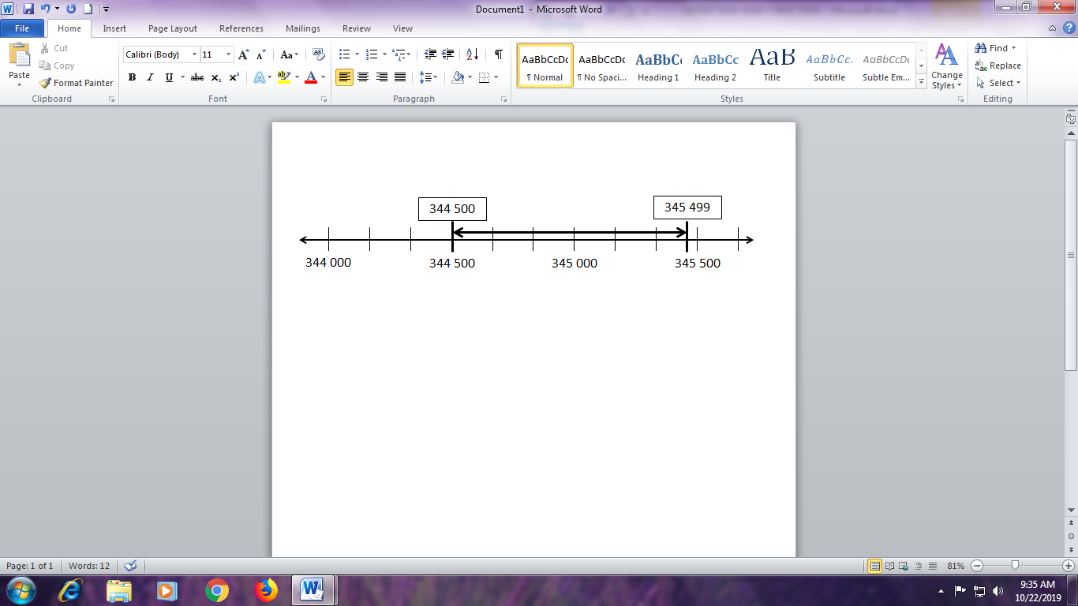  The possible numbers are from 344 500 to 345 499.  Therefore,  Largest possible number is 345 499 and  The smallest possible number is 344 500.  - Understand that there are situations when there is no need to calculate an exact answer and an estimate is good enough.  - Estimation method depends on the context of the situation.  - Shopping : If I have $100 in my pocket, I need to overestimate the price of each item to make sure the total amount does not exceed my pocket money.  Item Price Overestimate price  Earrings $4.80 $5  Shirt $17.50 $20  Jeans $22 $25  Dress $36 $40  Total $80.30 $90  - A birthday planner wants to prepare 30 goody bags. Each goody bag must contain 1 pack of Milo drink, 1 bag of Twisties, 2 Dairy Milk chocolate bars and 2 sticks of Chuppa Chups.  Each food item is available in bigger, economy family packs.  Food item Contents of each Economy pack  Milo drink Twisties Dairy Milk chocolate bars Chuppa Chups 1 pack of 4 1 pack of 10 1 pack of 20 1 pack of 15  How many of those bigger packs of each snack does the planner need to buy?  - Check answers to calculations involving whole numbers by  - Approximation by rounding to check whether the answer is the right order of magnitude.  Example: A tv costs $798. $798 is estimated to $800. It can’t be $700 or $70 or $80.  - Check answers by doing inverse operations.  Examples: By using a calculator to check  - 34 x 32 = 1088 with 1088 $÷$ 34  - 6 $÷$ 7 = 0.85714286 with 0.85714286 x 7  Check answers by doing an equivalent calculation.  Examples:  - Check 794 x 9 = 7146 with (800 – 6) x 9 = 7200 – 54 = 7146  Or 794 x (10 – 1) = 7940 – 794 = 7146  - Check 33 x 99 = 3267 with 33 x (100 – 1) = 3300 – 33 = 3267  Or (30 + 3) x 99 = 2970 + 297 = 3267  - A different method  Example: Find the approximate answer for 602 + 237  Estimation method 1 600 + 200 = 800  Estimation method 2 600 + 240 = 840  Which is the better estimate?  Use a calculator to check which the closer estimate is.  The estimated answer is close to the exact answer, therefore the calculation is likely correct.  - Decide when it is appropriate and when it is not appropriate to use a calculator to carry out calculations.  - The calculator is a tool to do calculations. The human brain and pencil and paper are also tools. Students should be taught when to use a calculator and when mental computing (or even paper & pencil) are more effective or appropriate. Choosing the right 'tool' is part of an effective problem-solving process.  - It is very important that students learn how to estimate the result before doing the calculation. A student must not learn to rely on the calculator without checking that the answer is reasonable.  - A calculator should not be used to try out randomly all possible operations and to check which one produces the right answer. It is crucial that students learn and understand the different mathematical operations so they know WHEN to use which one — and this is true whether the actual calculation is done mentally, on paper, or with a calculator.  - Solve one- and two-step word problems involving calculations with whole numbers.  Example: How many books costing $6 each can be bought for $56?  What operation (s) do we use?  Solve mentally, written or use a calculator?  Does the answer need to be rounded off?  - Know and use the order of operations to evaluate expressions:  - Brackets  - Powers or indices  - Multiplication & Division (from left to right)  - Addition & Subtraction (from left to right)  - Examples:  - Find mentally or use jottings to find the value of:  - $20 ÷5+10=14$  - $5+20 ÷10=7$  - $\frac{200}{4 ×5}=10$  - ${(3^{3}-5^{2})}^{2}$  - Evaluate:  - 289 $÷$ 3 + 98 – 7 $×$ 11  - $\sqrt{289}$ + 15 $÷$ 3 - $\sqrt[3]{729}$ $×$ 5  - $98-(132+84)÷12$  - Evaluate $\frac{1116}{(65-34)×12}$ using a calculator.  - Insert operation signs (i.e. $+ , - , × , ÷$) and brackets i.e. ( ), whenever necessary to make the following sentence correct.  $$3 5 2 = 21$$  - Number Sense Quizzes (No calculators!)  - A number N is multiplied by 30 and divided by 5. The result is 6. Find the value of N.  - True or false?  - 6³ is smaller than 3⁶. (T/F)  - 12² + 3² = 15². (T/F)  - 3(52 + 3 x 3) = 3 x 52 + 3 x 3 (T/F)  - Use the number line to introduce the idea of positive and negative integers.  - Negative integers are integers LESS than zero.  - Positive integers are integers GREATER than zero.  - ZERO is neither negative nor positive integer. We call it the origin.  Examples:  - Find the missing numbers:  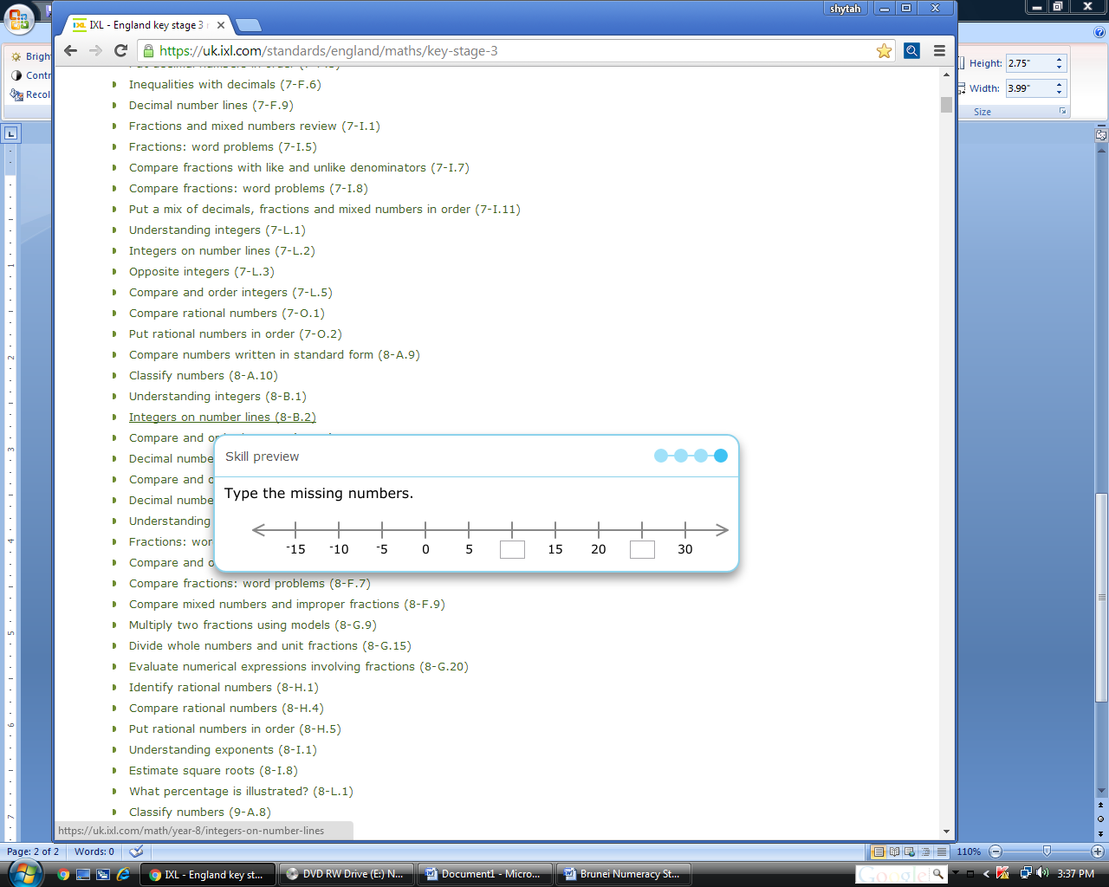  - 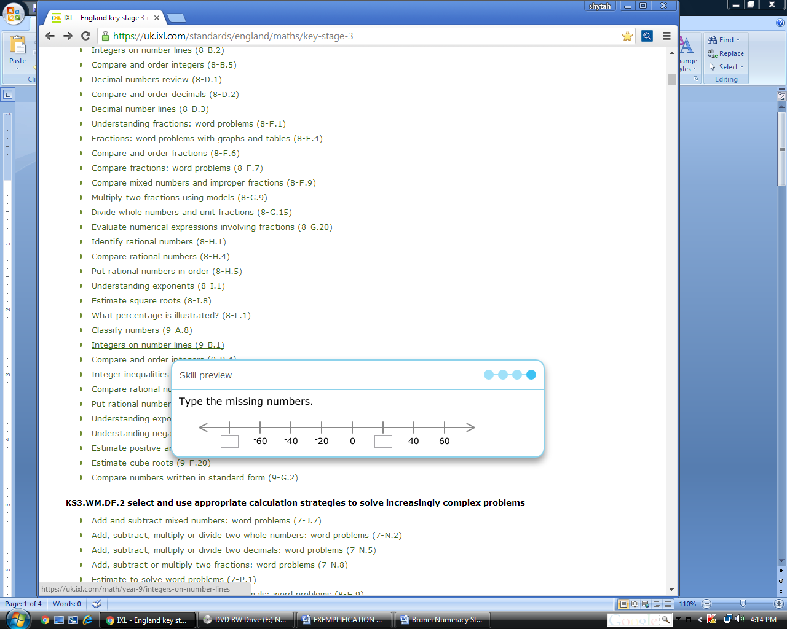  - Use integers in daily life.  - Explain the significance of negative numbers by providing daily examples: Ground Floor (0), Basement Floor (–1), 0⁰ C, –6⁰ C, 4 meters below sea-level, etc.  Examples:  Write an integer to describe each situation:  - A temperature of 10 degrees below zero.  - 20 feet below sea level.  - A $100 withdrawal.  - Lost 10 points.  - $50 deposit.  - A loss of $30.  - $60 price increase.  - $10 off the original price.  - 12 centimeters longer.  - Ascend 100 meters.  - Descend 200 meters.  - 7 students move away to a different school.  - Explain how the sum of two integers is obtained on the number line.  - Explain how the difference of two integers (especially one positive and the other negative) is obtained on the number line. Apply the idea to finding, e.g., the difference between two temperatures, 4⁰ C and –6⁰ C.  - Demonstrate addition, subtraction, multiplication positive and (or) negative integer by a positive integer on the number line and other models.  - Explore the rules for addition & subtraction and involving 2 integers using the calculator or other manipulative.  - Multiply positive and negative integers by a positive integer. , e.g.,  –3 x 2, 2 x (–6)  - Establish and use the basic rules for computing a pair of integers with a single operation (+, –, x), e.g., 4 x (–3) = –12, without the use of the calculator.  Examples:  - Evaluate $-23+\left(-8\right)-(-10)$,  - Find the difference between two temperatures, 4⁰ C and –6⁰ C.  - Write down the missing values.  - ____ + 3 = $-$1  - 8 $-$ ____ = 6  - ____ $× -$2 = $-$10  - 4 $×$ ____ = $-$12  - What are the two integers, when added together, will give $-4$ as the answer? Are there any other possible pairs of integers which when added, will give the same answer?  - Mt. Everest, the highest elevation the world, is 8 850 meters above sea level. The Dead Sea, the lowest elevation, is 413 meters below sea level. What is the difference between these two elevations?  - A submarine hovers at 340 meters below sea level. If it descends 120 meters and then ascends 290 meters, what is its new position?  - Chen has overdrawn his checking account by $27. His bank charged him $15 for an overdraft fee. Then he quickly deposited $100. What is his current balance?  - The price of a share of stock started the day at $37. During the day it went down $3, up $1, down $7, and up $4. What was the price of a share at the end of the day?  - Arief is planning to go on a holiday. He searched the Internet to find out the average temperature of different cities in December. The table below shows his findings.  City Singapore Moscow Paris Melbourne Seoul  Average temperature (⁰C) 28 $$-5$$ 6 24 $$-1$$  - Where can he go if he plans to go to the city where the temperature is  - Below $0℃$  - Between $-10℃$ and $0℃$  - Above $20℃$  - What is the difference in average temperature between Singapore and Moscow?  - Where is it colder, Moscow or Seoul?  - The average temperature in Taipei is exactly midway between the temperatures in Singapore and Moscow. What is the average temperature in Taipei?  - The diagram below shows the position of a bird and a submarine from either above or below sea level. The submarine is at 550 metres below sea level.  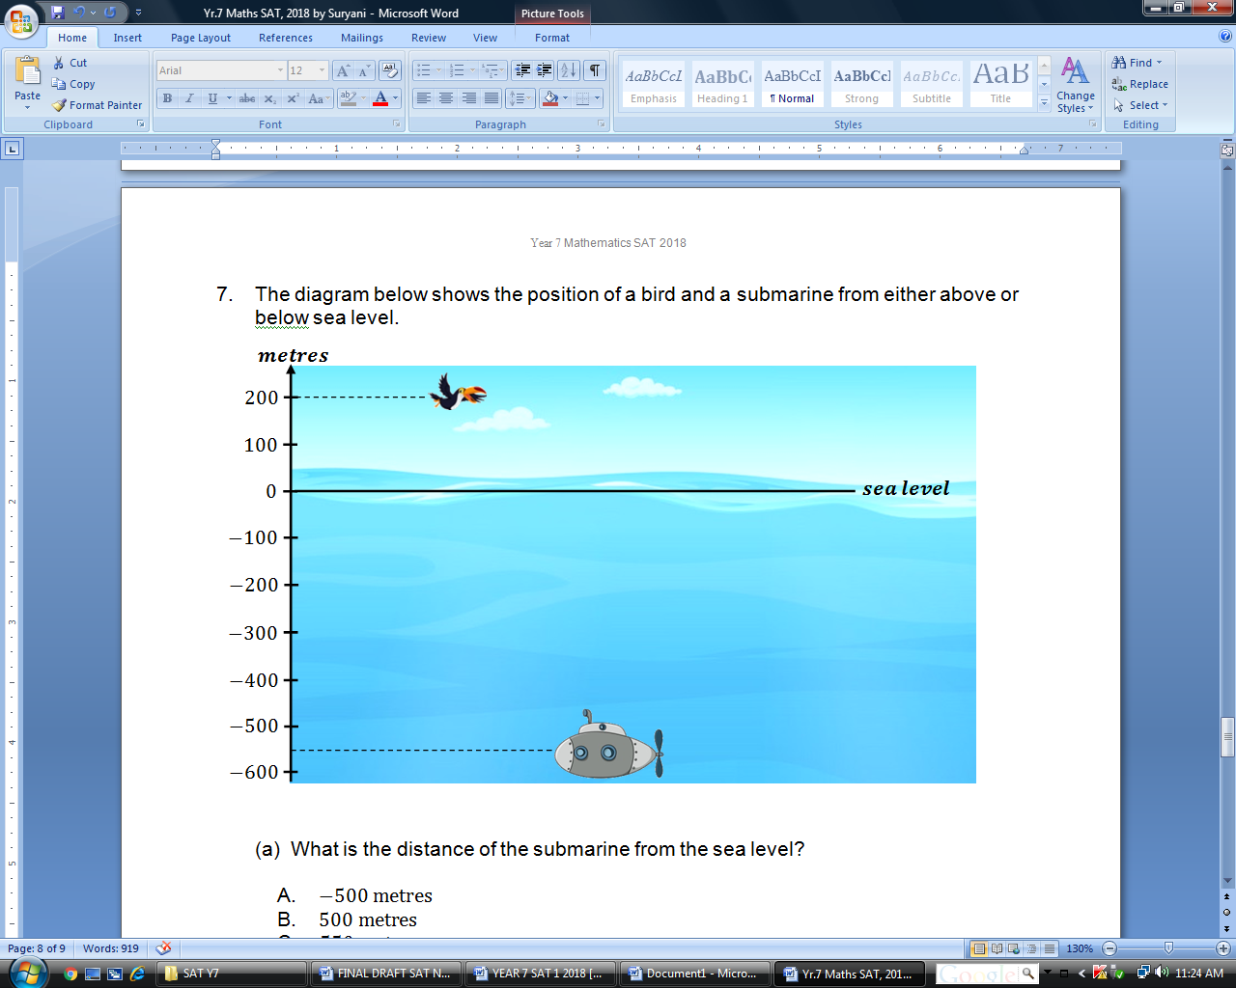  - What is the distance between the bird and the submarine?  - A radar system can detect submarines down to 250 metres below sea level. How many metres can the submarine climb if the submarine is to be 50 metres below the level of detection?

SUB-TOPICS | LEARNING OUTCOMES | LEARNING EXPERIENCE/EXEMPLIFICATION | INSTRUCTION TIME
1.3 OPERATIONS WITH FRACTIONS AND DECIMALS | Students should be able to: |  | 2
1.3.1 Decimal Number Bonds, Double & Corresponding Halves, Multiplication & Division of Decimals  1.3.2 Estimation & Approximation  1.3.3 Word Problems  1.3.4 Addition & Subtraction of Fractions  1.3.5 Multiplication & Division of Fractions  1.3.6 Ordering of Integers, Decimals & Fractions | - Consolidate the rapid recall of number facts including:  - complements (number bonds) for decimals with one and two decimal places to 1;  - doubles of 2-digit decimal numbers and corresponding halves.  Consolidate mental methods for calculating with decimals, including multiplication and division by 10, 100 and 1000.  - Make and justify estimates of calculations involving decimals.  - Understand and use place value to solve problems involving decimals, including problems that require numbers to be rounded to the nearest 0.01, 0.1, etc.  Understand the concept of ‘decimal places’ and use it to round decimals to up to three decimal places when solving problems.  - Choose when it is appropriate and when it is not appropriate to use a calculator to carry out calculations.  Use a calculator efficiently, checking answers appropriately.  - Solve one- and two-step word problems involving calculations with decimals choosing appropriately:  - the operation(s) to use;  - whether to use mental, written or calculator method(s);  - whether the answer needs to be rounded due to the context of the problem.  - Check answers to calculations involving decimals by using:  - approximations, to verify whether the answer is the right order of magnitude;  - inverse operations and working the problem backwards;  - a different method.  - Add and subtract fractions and mixed numbers, mentally or with jottings when appropriate.  - Multiply and divide fractions, interpreting division as a multiplicative inverse.  - Solve problems involving comparisons and ordering of integers, decimals and fractions in a range of different contexts including those involving different units of measurement, using the symbols =, ≠, <, ≤, >, ≥. | - Complements (number bonds)  Derive quickly: decimal complements in 1 (one and two decimal places),  Examples: 1 = 0.8 + 0.2, 1 = 0.41 + 0.59  0.3 and what number makes 1?  0.3 + 0.7 = 1 or 1 – 0.3 = 0.7  - Doubles and halves  Derive quickly: doubles of two digit decimal numbers,  Examples: 3.8 x 2, 0.76 x 2  and all the corresponding halves.  Example: What is double of 2.2? 2.2 + 2.2 = 4.4 or 2x2.2 = 4.4  Correspondingly, half of 4.4? $4.4÷2=2.2$  - Use knowledge of place value to multiply and divide mentally decimal numbers by 10, 100 and 1000, or by a small multiple of 10,  e.g. 4.3 x 100, 1.6 x 20 = 1.6 x 10 x 2 =16 x 2 = 32,  ______ $÷$ 100 = 4.7  - Use knowledge of multiplication facts and place value to multiply mentally.  Examples:  - 0.2 x 8 = 10 x 0.2 x 8 = 2 x 8 = 16 ÷10 = 1.6  - 0.04 x 9  - 8 x 0.5  - 7 x 0.03  - ____ x 0.2=10  - 80 x ____ =8  - The decimal point is missing. Put it in.  - 15.25 x 4.6 = 7 0 1 5  - 234.5 x 0.52 = 1 2 1 9 4  - Examples:  - Find an estimate of:  - 2.13 x 5.71  - 6641 ÷ 21.3  - (42.4 x √51) ÷ 21.3  - One kilogram of fish was sold for $4.95. Estimate how many kilograms of fish you could buy with $20.  - Number Sense Quizzes (No calculators!)  - Without working out the exact answers, tell True or False:  - (230 x 0.996) > 230  - 2.6 – ½ > 2  c) ¾ x 62 ÷ 0.89 is less than 45  d) 0.125 x 8200 < 1000  e) √2500 < 15  - Understand that there are situations when there is no need to calculate an exact answer and an estimate is good enough (underestimate/overestimate).  Example: Safwan wants to make a small doll house using planks of woods. The house requires 2.3 m of wooden planks. Each wooden plank is one meter long. How many pieces of wooden planks does Safwan need to make the doll house?  - Examples:  - Round off 1.2468 to:  - the nearest tenth,  - the nearest hundredth,  - 3 decimal places.  - Use a calculator appropriately.  - The calculator is a tool to do calculations. The human brain and pencil and paper are also tools. Students should be taught when to use a calculator and when mental computing (or even paper & pencil) are more effective or appropriate. Choosing the right 'tool' is part of an effective problem-solving process.  - It is very important that students learn how to estimate the result before doing the calculation. A student must not learn to rely on the calculator without checking that the answer is reasonable.  - A calculator should not be used to try out randomly all possible operations and to check which one produces the right answer. It is crucial that students learn and understand the different mathematical operations so they know WHEN to use which one - and this is true whether the actual calculation is done mentally, on paper, or with a calculator.  - Solve one- and two-step word problems involving calculations with decimals  Example: A pear costs $1.20 each. What is the maximum number of pears I could get if I only have $10 inside my wallet?  What operation (s) do we use?  Solve mentally, written or use a calculator?  Does the answer need to be rounded off?  Examples:  - A cook bought 224.5 kilograms of almonds and 1.6 kilograms of pecans. How many kilograms of nuts did the cook buy in all?  - A supermarket sells 1 kg of whole chicken for $3.50. Khadijah bought a whole chicken weighting as shown below. How much did she pay for the chicken?  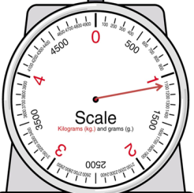  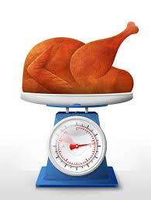  - A donut store uses 1.6 kg of sugar each hour. How many kilograms of sugar will the store use in 17 hours?  - A drink and a box of chocolate together cost $4. Two drinks and a box of chocolate together cost $5.50. How much is a box of chocolate?  - Five friends went to a restaurant for lunch. The total cost for the set menu was $66. Two more friends came to join the lunch. How much did the set menu cost altogether?  - Check answers by  - Approximation by rounding to check whether the answer is the right order of magnitude. Example: A book costing $26.40 is estimated to $27. It can’t be $25 or $2.  - Check answers by doing inverse operations.  Examples:  - Check 15.9 x 3.2 = 50.88 with 50.88 $÷$ 15.9  - Check 99.78 $÷$ 5.3 = 18.8264151 with 18.8264151 x 5.3  - A different method  Example: $25.2 ÷4.9$  Estimated answer $25 ÷ 5= 5$ or 25.5 ÷ 5 = 5.1,  Which one is the better estimate?  Exact answer $25.2 ÷4.9=5.14$  The estimated answer is close to the exact answer, therefore the calculation is likely correct.  - Mental arithmetic  - What is the sum of 30 tens and 4 tenths?  - What is the value of 5 tenths less than twenty and sixteen hundredths?  - Add and subtract simple fractions and mixed numbers, mentally or with jottings when appropriate.  Examples:  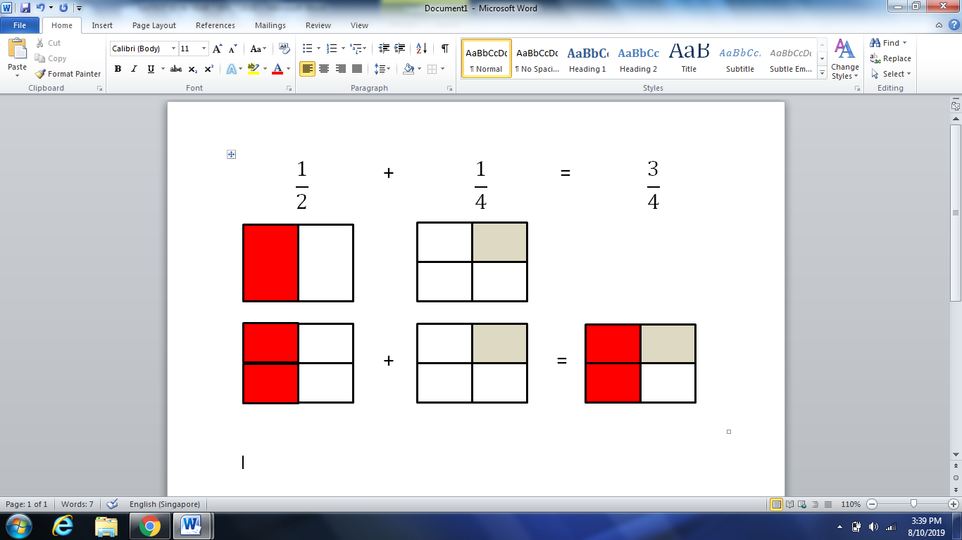  - At a pie-eating contest, Ayden got through $\frac{2}{3}$ of a pie before time was called. Malek finished just $\frac{7}{12}$ of a pie. How much more pie did Ayden eat than Malek?  - My mother made 6 bowls of pasta. She puts extra cheese on 3 of them. What fraction of the bowls did not have extra cheese?  - Find the fraction which is mid-way between 3/8 and ½.  - In $\frac{4}{5}= \frac{4 +9 }{5 + ?_}$ , what is the missing number?  - Multiply and divide simple fractions  Multiplicative inverse: Two numbers whose product is $1$ are multiplicative inverses of one another.  For example, $\frac{3}{5}$ and $\frac{5}{3}$ are multiplicative inverses of one another because $\frac{3}{5}×\frac{5}{3}=\frac{5}{3}×\frac{3}{5}=1$.  - Examples:  - Use the model to find the product.  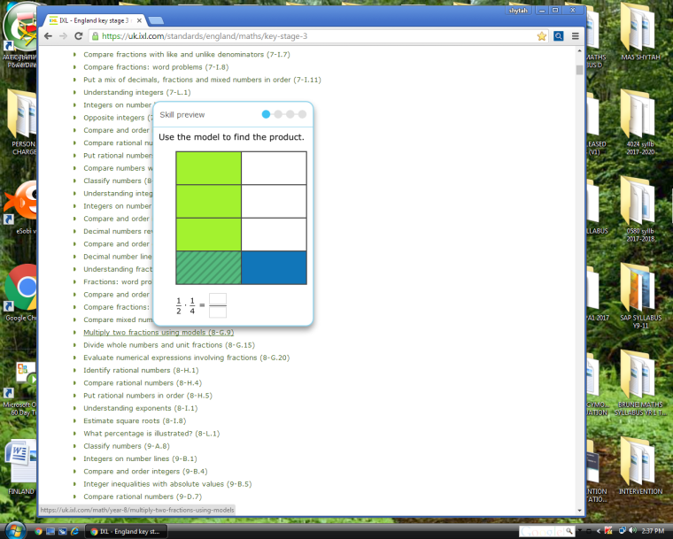  $\frac{ 1}{2}×\frac{1}{4}$= ____  - Calculate five-eighths of fourteen dollars.  - Ahmad has 2 pieces of papers. He wants to split them into $\frac{1}{4}$ pieces. How many pieces will he get in total?  - Aqil has 15 shirts in his closet. If 2 out of every 3 of these shirts are striped, how many unstriped shirts does he have in his closet?  - Khairi and Zul sold candies to raise money for their debate team. Zul sold 3 times as much candies as Khairi did. If Khairi sold $\frac{1}{2}$ of a box of candies, how many boxes of candies did Zul sell?  - $\frac{1}{3}$ of a number is 4. What is the number?  - Examples:  - Without working out the answers, tell True or False:  - 0.3 – 0.125 > 1/5 (b) ¾ + ½ > 1  (c) 62 ÷ 0.89 is less than 62. (d) 19/8 – 8/19 < 2  2. Rewrite the following numbers in ascending order:  6.1 , 5.444 , $6\frac{4}{5}$, - 6.1 , 5.4 , $\frac{39}{8}$ , $-2$  - A supermarket found that $\frac{5}{9}$ of the customers bought vegetables and $\frac{5}{8}$ of the customers bought fruits. Which purchase was made by a greater fraction of customers?  - Fill in the missing values in decimal form.  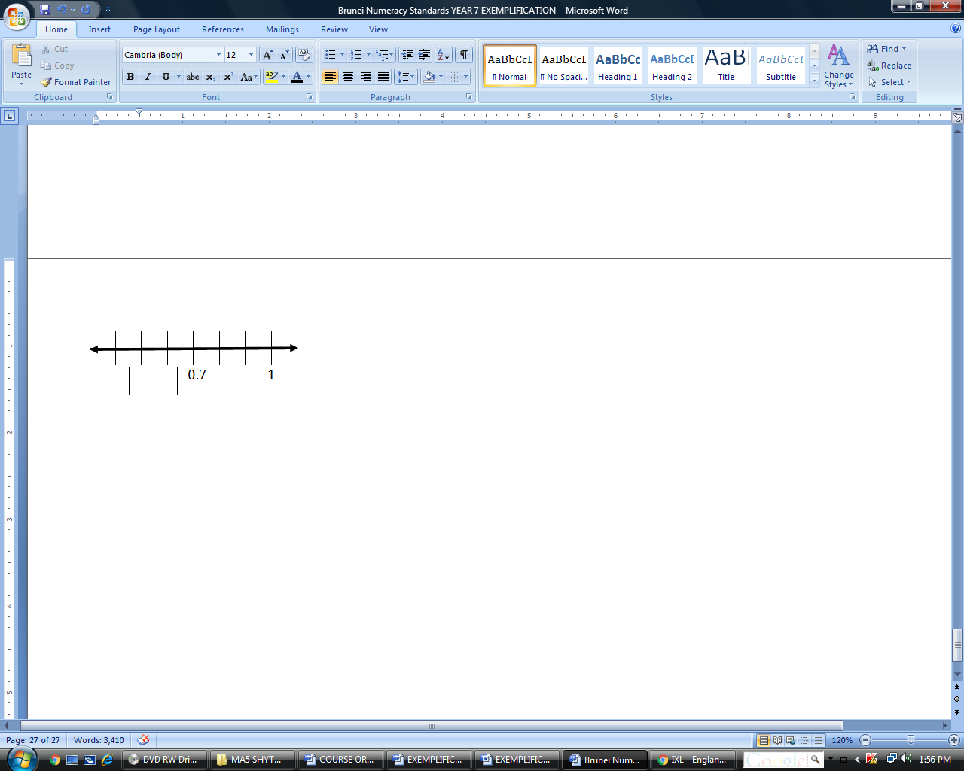  - Which sign makes the statement true?  - $________$ $5.90 × {10}^{1}$  $$<$$ $$>$$ $$=$$  - Select $< , >or=$ to make the statement true.  $1 000 centimeters$ ______ $10 meters$  - What is the missing fraction in the box?  2.07 = 2 +  - Circle the fraction that represents the largest amount:  $$\frac{15}{16} , \frac{16}{17} , \frac{19}{20} , \frac{18}{19}$$  - Julie and Sharil each bought a bag of grapes. The bag of grapes Julie bought weighed $\frac{4}{10}$ kg while Sharil’s bag of grapes was $0.5$ kg. Whose bags of grapes weigh more?

SUB-TOPICS | LEARNING OUTCOMES | LEARNING EXPERIENCE/EXEMPLIFICATION | INSTRUCTION TIME
1.4 RATIO & PROPORTION | Students should be able to: |  | 2
- Ratio & Proportion  - Ratios in their simplest forms.  - Divide a quantity into parts of a given ratio.  - Solve ratio & proportion problems  - Rate | - Understand and recognise proportionality and the relationship between ratio and proportion.  - Determine whether or not two ratios are in proportion.  - Express ratios of two or three quantities in their simplest form.  - Divide a quantity into two or three parts in a given ratio.  - Solve simple ratio and proportion problems using informal methods, including those involving scales on maps or diagrams.  - Understand rate as a comparison, or ratio, of two measurements with different units. | - Ratio is a comparison of two things. Ratios can be written in several different ways: as a fraction, using the word "to", or with a colon.  Ways to write ratio of squares to triangles:  As a fraction Ratio of squares to triangles is $\frac{3}{6}$  Using “to” Ratio of squares to triangles is 3 to 6  Using a colon Ratio of squares to triangles is 3 : 6  - To find an equivalent or equal ratio, you can either multiply or divide each term in the ratio by the same number (but not zero).  $$3 :6=6 :12=30 :60=1 :2$$  - Two equivalent or equal ratios can be written in 2 ways:  As two equal fractions $$\frac{3}{6}= \frac{6}{12}$$  Using a colon $$3 :6=6 :12$$ (Read as three is to six as six is to twelve)  - Proportion is two equivalent/ equal ratios  The ratios $3 :6=6 :12$ (or$\frac{3}{6}= \frac{6}{12}$) are equivalent or equal.  Therefore, $3 :6=6 :12$ (or$\frac{3}{6}= \frac{6}{12}$) are in proportion or proportional.  - Ratio compares part to part whereas proportion compares part to whole.  - Proportion can be expressed in each of the following forms:  Frequency 9 out of 10  Ratio 9 : 10  Fraction $$\frac{9}{10}$$  Rate 0.9  Percentage 90%  - Examples:  - Ingredients to make Milo drink:  1 cup of Milo 5 cups of Milo  2 teaspoons Milo powder 10 teaspoons Milo powder  1 teaspoon creamer 5 teaspoons creamer  1 cup of water 5 cups of water  The ratio of Milo powder 1 cup : 5 cups 2 teaspoons : 10 teaspoons = 2 : 10 = 1 : 5 The ratio of creamer 1 cup : 5 cups 1 teaspoons : 5 teaspoons = 1 : 5  2:10 and 1:5 are equivalent ratios.  We say that the ratio of Milo powder is proportional to the ratio of creamer.  - Complete the ratio table  3 5  6 10  ____ 25  30 _____  _____ 60  - Are the ratios $1 :2$ and $3 :6$ equivalent?  - Are these ratios equivalent?  - 4 bags to 8 purses  - 5 bags to10 purses  - Are 1 : 2 and 5 : 10 in proportion?  Use cross multiplication,  $$\frac{1}{2}= \frac{5}{10}$$  $$\frac{1}{2} ×2 ×10= \frac{5}{10} ×2 ×10$$  $$10 = 10$$  Hence 1 : 2 is proportional to 5 : 10 since their cross multiplication is equal.  - Are 4 : 3 and 16 : 13 in proportion?  Use cross multiplication,  $$\frac{4}{3}= \frac{16}{13}$$  $$\frac{4}{3} ×3 ×13= \frac{16}{13} ×3 ×13$$  $$52 ≠ 48$$  Hence 4 : 3 is not proportional to 6 : 13 since their cross multiplication is not equal.  - Do the ratios $\frac{3}{2}$ and $\frac{9}{6}$ form a proportion?  - 3:5 and 12:20 are equal ratios?  - To simplify a ratio means to reduce it to its smallest, simplest, terms.  - Examples:  - Simplify the ratio 25 : 40  - Simplify the ratio 12 : 6 : 60  - Divide a quantity into two or three parts in a given ratio.  Examples:  - Divide 60 into two parts in the ratio 2 : 3  - Divide $50 in the ratio 3 : 2  - Divide 81 m in the ratio 2 : 7  - Divide 200 sweets into 3 parts in the ratio 3 : 6 : 1  - Divide $ 120 between Morgan and Jack in the ratio 3 : 5.  - Salmah gave $100 to her daughter Ain and asked her to spend three parts and save two parts of the total amount. How much did Ain spend and how much did she save?  - Divide $260 among Aishah, Buzz and Charlie in the ratio  1/2 : 1/3 : 1/4.  - Two numbers are in the ratio 5 : 7. If the difference between the numbers is 24, find the numbers.  - Examples:  - A survey was conducted to find out about students’ favourite colours. In 7J, 10 students said their favourite colour was blue while 5 students preferred red. Meanwhile, in 7C, 12 students said their favourite colour was blue while 10 students preferred red. Which class has a higher ratio of students who preferred blue to students who preferred red?  - 2 apples cost $2.20. Find the cost of 5 apples.  2 apples --------------------- $2.20  4 apples --------------------- $2.20 x 2 (double) = $4.40  2 apples --------------------- $2.20  1 apple --------------------- $\$2.20÷2$ (half) = $1.10  Cost of 5 apples = Cost of 4 apples + Cost of 1 apple  = $4.40 + $1.10  = $5.50  - Is 6 for $0.85 better than 8 for $1.00?  - Brunei Dollars can be exchanged for Malaysian Ringgit.  B$30 = RM90. How much RM can be exchanged for B$100?  - A SCALE DRAWING is a diagram/map/model of an object that is too large or too small to draw. The dimensions are proportional to the actual dimensions (distances) of the real-life example. *Maps, blue prints, floor models are some examples.  The SCALE on a scale drawing is the ratio of the drawing lengths or model to its corresponding actual lengths.  “1 cm : 5 m” means that 1 cm in the model represents an  actual distance of 5 m.  “Scale” dimensions in the scale drawing.  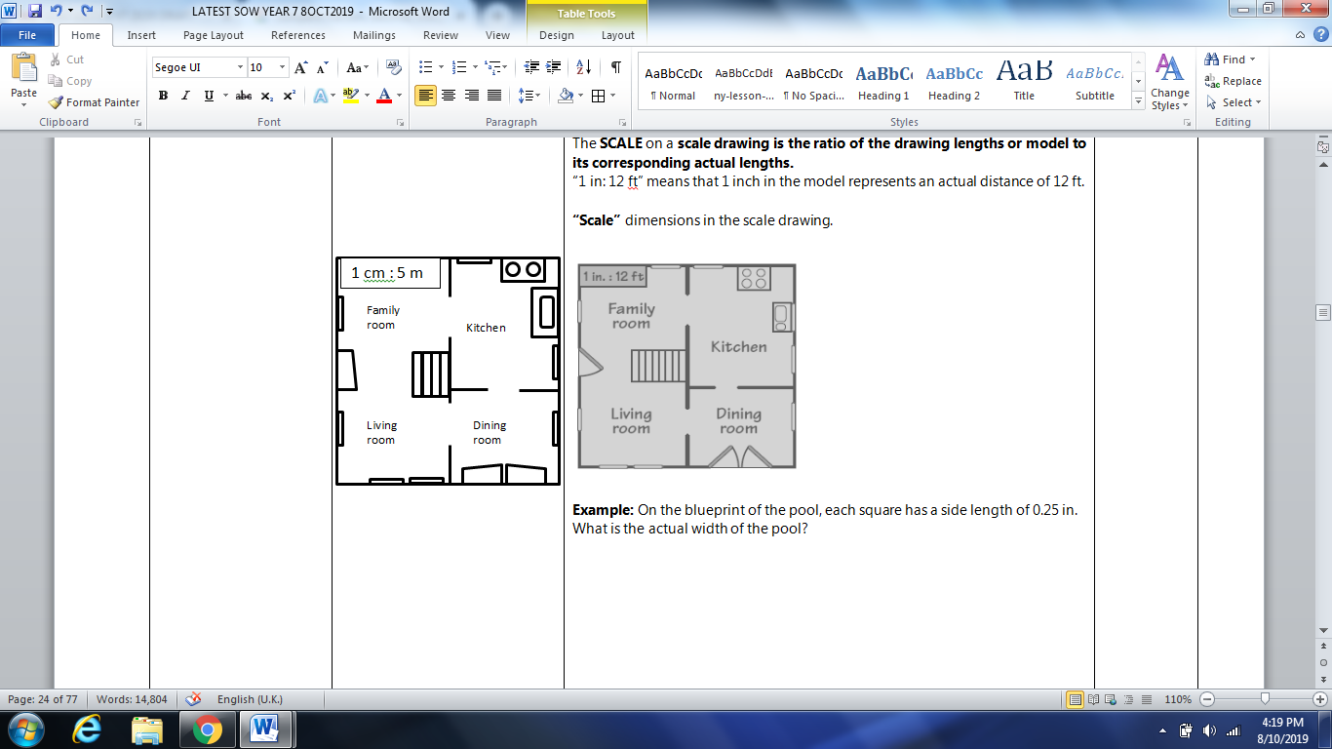  - Example: On the blueprint of the pool, each square has a side length of 0.2cm. What is the actual width of the pool?  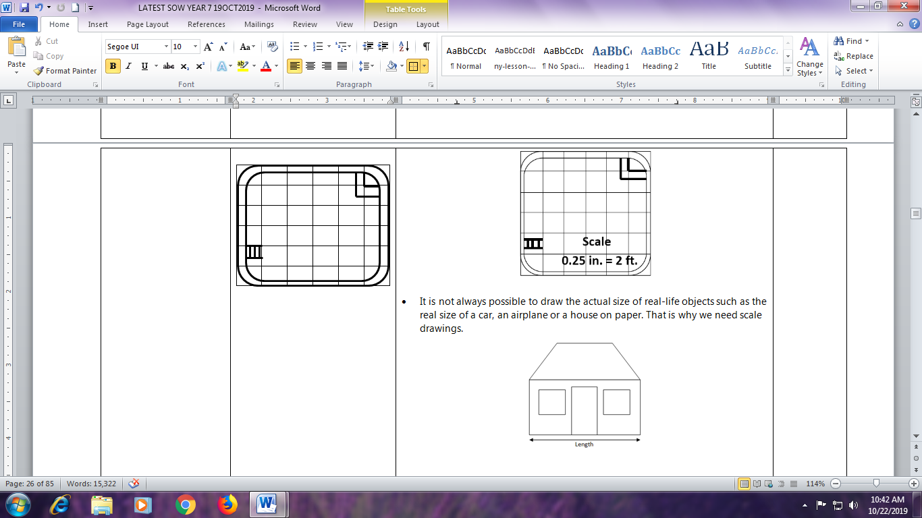 Scale 0.2 cm = 2 m  - It is not always possible to draw the actual size of real-life objects such as the real size of a car, an airplane or a house on paper. That is why we need scale drawings.  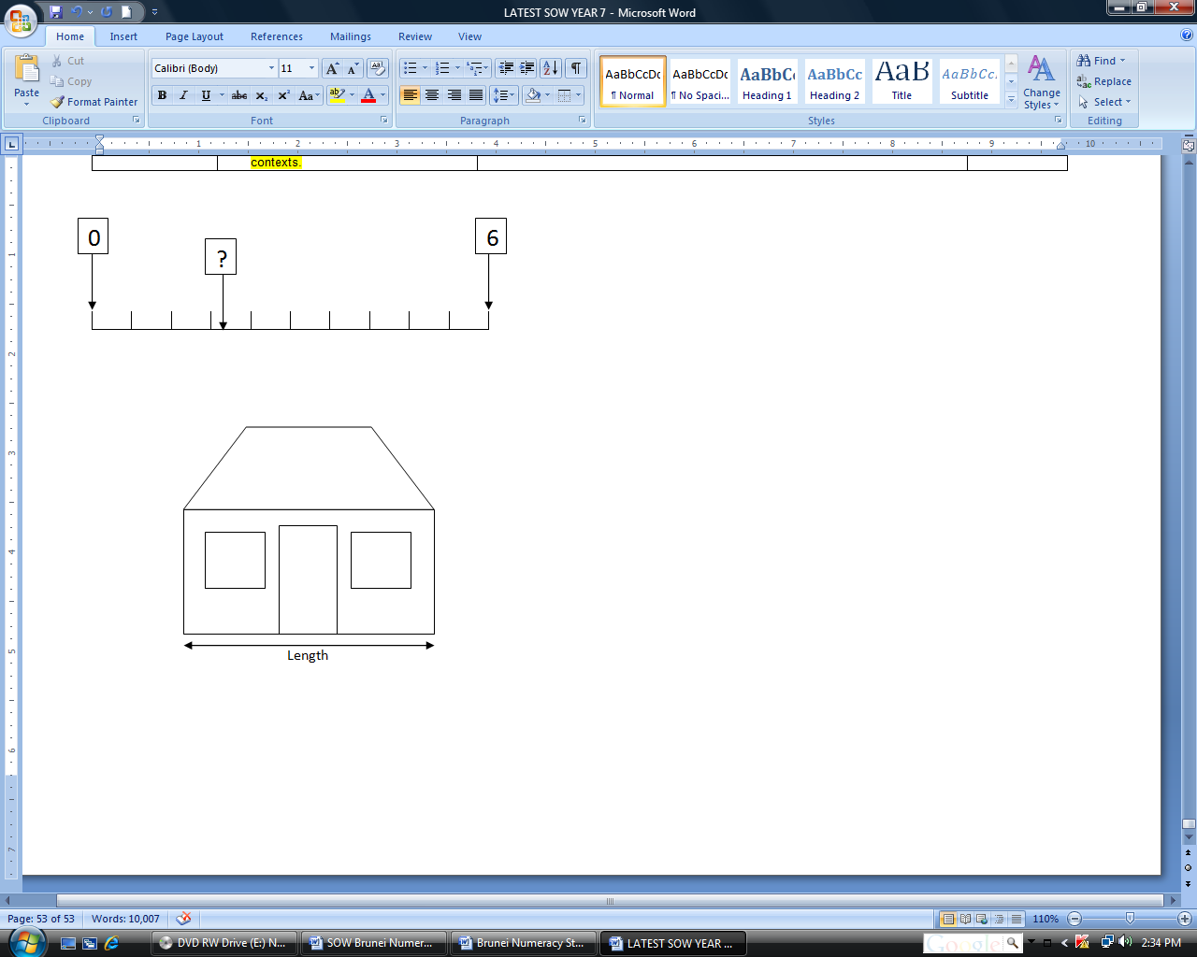  In real-life, the length of this house may measure 900 centimeters. The length of an A4 paper is about 30 centimeters.  $\frac{900}{30}=30$, therefore we will need about 30 sheets of A4 papers to draw the length of the actual size of the house.  In order to use just 1 sheet of A4 paper, we could use 1 centimeter on our drawing to represent 30 centimeters on the real-life object.  We can write this situation as 1 : 30 or $\frac{1}{30}$ or 1 to 30.  Note: The first number always refers to the length of the drawing on paper and the second number refers to the length of the real-life object.  - Example: The length of a car is drawn to scale of 1 : 40. The length of car on paper is 12 cm long. Calculate the actual length of the car.  1 cm on paper = 40 cm in real life  2 cm on paper = 2 x 40 = 80 cm in real life (double of 1 cm)  12 cm on paper = 6 x 80 cm = 480 cm in real life (6 times 2 cm)  - Rate is how much of something per 1 unit of something else.  Examples:  - 1000 cars pass by in 4 hours.  1000 cars = 4 hours  $\frac{1000}{4}$ = 1 hour  The unit rate is 250 cars per hour.  - 100 packets of Nasi Katok were eaten by 50 people. The unit rate is 2 packets of Nasi Katok per person.  - The car can go 1000 km on 50 liters of fuel. The unit rate is 20 km per liter.  - There are 120 students and 4 teachers. The unit rate is 30 students per teacher.  - In the last 4 weeks Sam earned $4000. The unit rate is $1000 per week.  - Examples:  - The table shows the parking rates at a car park.  Parking rates  First 10 km $1.20  Every additional km or part thereof 80 cents  - Calculate the total fare, in dollars, for the journey of  - 8 km,  - 24 km.  - Find the length of the journey for which the fare was $16.  - Last week I paid $5.30 for 2 kg of durians.  This week I paid $11.10 for 3 kg of durians.  What was the difference in the price per kg?  - Hajah Salmah wants to buy a bottle of cooking oil.  Cooking Oil Brand Y  1 kg at $4.35 500 g at $2.60  Which cooking oil is of better value, the 1 kg bottle or 500 g bottle? Explain.

SUB-TOPICS | LEARNING OUTCOMES | LEARNING EXPERIENCE/EXEMPLIFICATION | INSTRUCTION TIME
1.5 PERCENTAGES | Students should be able to: |  | 2
- Percentages & their equivalent fractions & decimals  - Expressing one quantity as a percentage of another.  - Calculating percentages of quantities | - Understand percentage and recognise the equivalence of percentages, fractions and decimals.  Express percentages as decimals or fractions.  - Express one quantity as a percentage of another and use this in problems to compare simple proportions.  - Calculate percentages of quantities, mentally and through jottings. | - Recall percentages, fractions and decimals facts such as:  $$\frac{1}{4}=25\% or 0.25$$ $$\frac{1}{2}=50\% or 0.5$$ $$\frac{3}{4}=75\% or 0.75$$  $$1=100\% or 1.0$$ $$\frac{9}{10}=90\% or 0.9$$ $$0.37=37\% or \frac{37}{100}$$  $67\%=0.67 or \frac{67}{100}$  - Find the equivalence of percentages, fractions and decimals  Examples:  - Express 37% as a fraction and a decimal  $37\%$ is equivalent to $\frac{37}{100}=0.37$  - Express 70% as a fraction in its lowest terms.  70% is equivalent to $\frac{70}{100}= \frac{7}{10}$  - Express $\frac{2}{5}$ as a percentage  $\frac{2}{5}= \frac{4}{10}= \frac{40}{100}=40\%$  - Convert $\frac{1}{8}$ into a decimal  $\frac{1}{4}=0.25$ so $\frac{1}{8}=0.25 ÷2=0.125$  - Fill in the equivalent decimal, fraction & percentage in each of the following  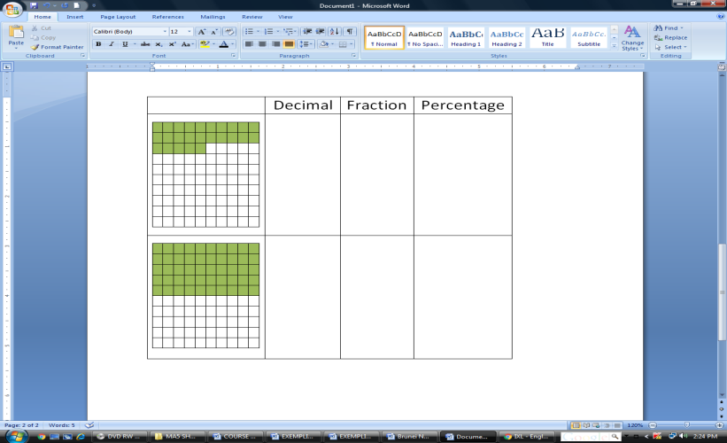  - Find simple equivalent fractions:  Example: What are the two fractions equivalent to $\frac{4}{5}$  $$\frac{8}{10} , \frac{12}{15}$$  - Examples:  - There are 100 flowers in the basket. 40 of them are yellow.  - What fraction of the flowers is yellow?  - What percentage of the flowers is yellow?  - There are 400 students in a school. 240 of them are boys. Express the number of boys as a percentage of all students in the school?  - Express 500 g as a percentage of 2.5 kg.  - A survey was conducted to learn people’s chocolate preferences:  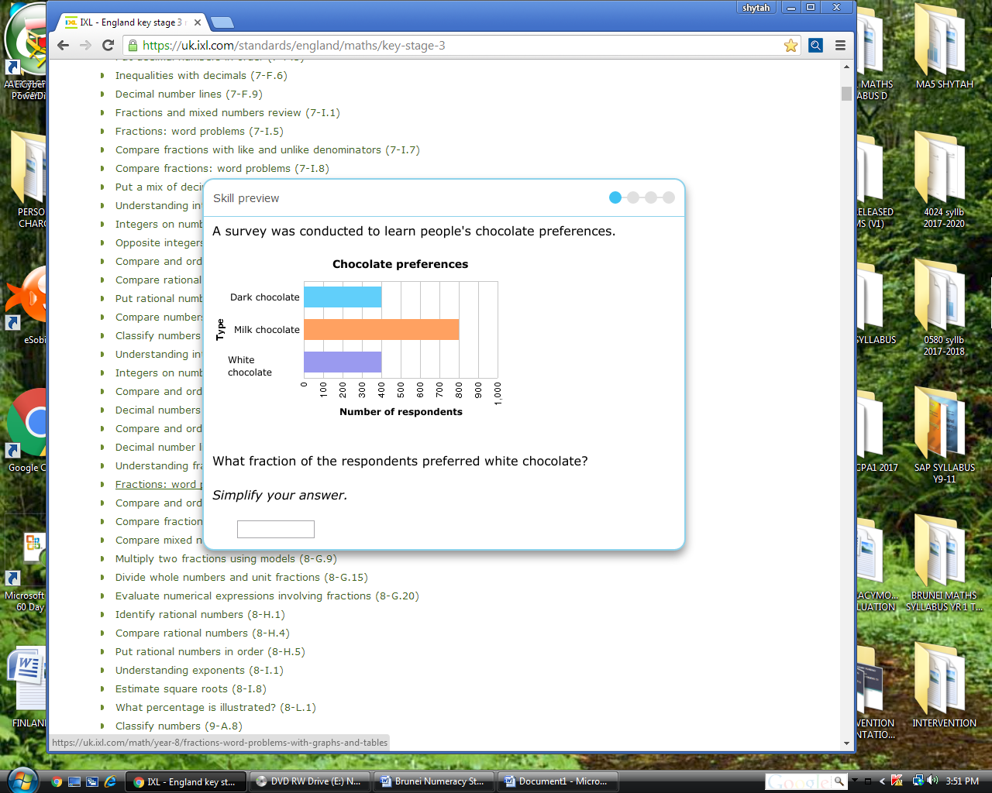  - What fraction of the respondents preferred dark chocolate?  - What percentage of the respondents preferred milk chocolate?  - A serving of ice cream contains 5000 calories. 200 calories come from fat. What percent of the total calories come from fat?  - In a box of 8 doughnuts, two have red sprinkles. How many percent of the doughnuts have red sprinkles?  - What percent of 1 hour is 15 minutes?  - Examples:  - Calculate 40% of 35 kg  10% of 35 = 3.5  20% of 35 = 3.5 x 2 = 7  40% of 35 = 3.5 x 4 or 7 x 2 = 14 kg  - 20% of a number is 40. What is the number?  20% of the number = 40  40% of the number = 40 x 2 = 80  100% of the number = 40 x 5 = 200  - The monthly budget for the front of the house is $5000. My mother spent 10% of the budget on fresh flowers. How much did she spend on fresh flowers?  100% of $5000 = $5000  10% of $5000 = $5000$÷$10 = $500  - Out of 1200 students in a school, only 85% passed. Find how many students failed.  % of students who failed = 100% - 85% = 25%  100% of 1200 students = 1200 students  50% of 1200 students = 1200$÷$ 2 = 600 students  25% of 1200 students = 600 $÷$ 2 = 300 students failed

SUB-TOPICS | LEARNING OUTCOMES | LEARNING EXPERIENCE/EXEMPLIFICATION | INSTRUCTION TIME
- SEEING, EXPRESSING & RECORDING ALGEBRAIC RELATIONSHIPS  (Link to 1.2.6) | Students should be able to: |  | 2
1.6.1 Unknowns & variables.  1.6.2 Algebraic expressions & arithmetic Operations  1.6.3 Constructing algebraic expressions  1.6.4 Constructing simple linear equations | - Understand the concepts of an unknown and a variable.  Understand the vocabulary of algebra: expression; equation; formula; term; constant; linear; evaluate; simplify; substitute; solve; factorise; expand.  Recognise and use algebraic conventions when representing unknown numbers or variables in expressions and equations  (e.g. 3n, a – 7, 2n + 4, ª/₂, 3 (n + 4), 4x – 1 = 7, 2 (a + 3) = 14).  - Understand that algebraic expressions follow the same conventions and order as arithmetic operations, including the use of brackets.  - Generalise rules from simple practical situations and construct algebraic expressions using symbols to represent these.  Express previously learned simple mathematics formulae algebraically (e.g. P = 2l + 2w).  - Express ‘Think of a number’ type problems as mappings, using symbols to represent the unknown number.  Construct simple linear equations (integer coefficients and constants, unknown on one side only) to express unknown number problems arising from practical situations. | Algebra is based on the concept of unknown values called variable.  A variable is a letter representing some unknown; an unknown quantity or expression whose value can change.  A constant is a value or number that never changes in an expression it’s constantly the same.  A term is a part of an expression separated by + or - signs.  A coefficient is a numerical or constant quantity placed before and multiplying the variable in an algebraic expression.  An expression is a combination of variables, numbers, and/or operations that represents a mathematical relationship. It does NOT have an equal sign.  An equation is a mathematical statement that two or more expressions are equal. It must have an equal sign.  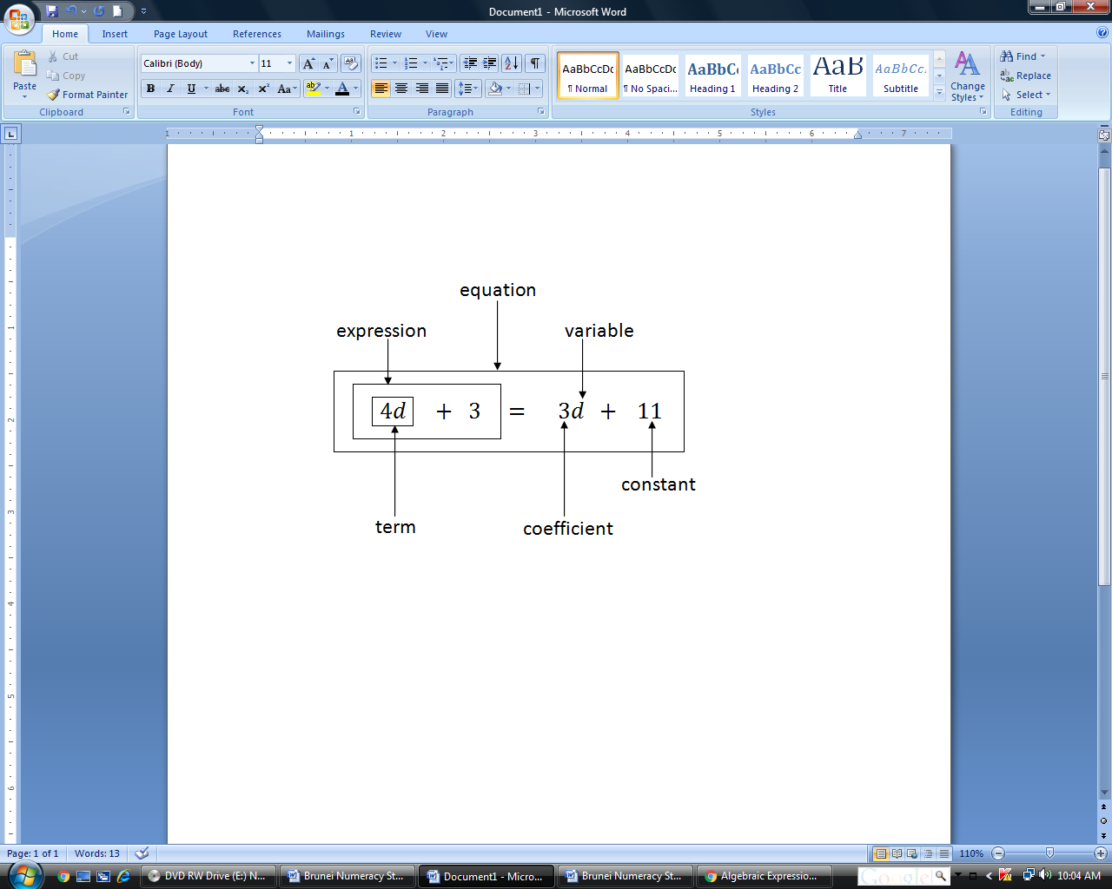  - Examples:  - Fauzan had 15 cookies at first. How many cookies had Fauzan left if he gave Nani  - 5 cookies?  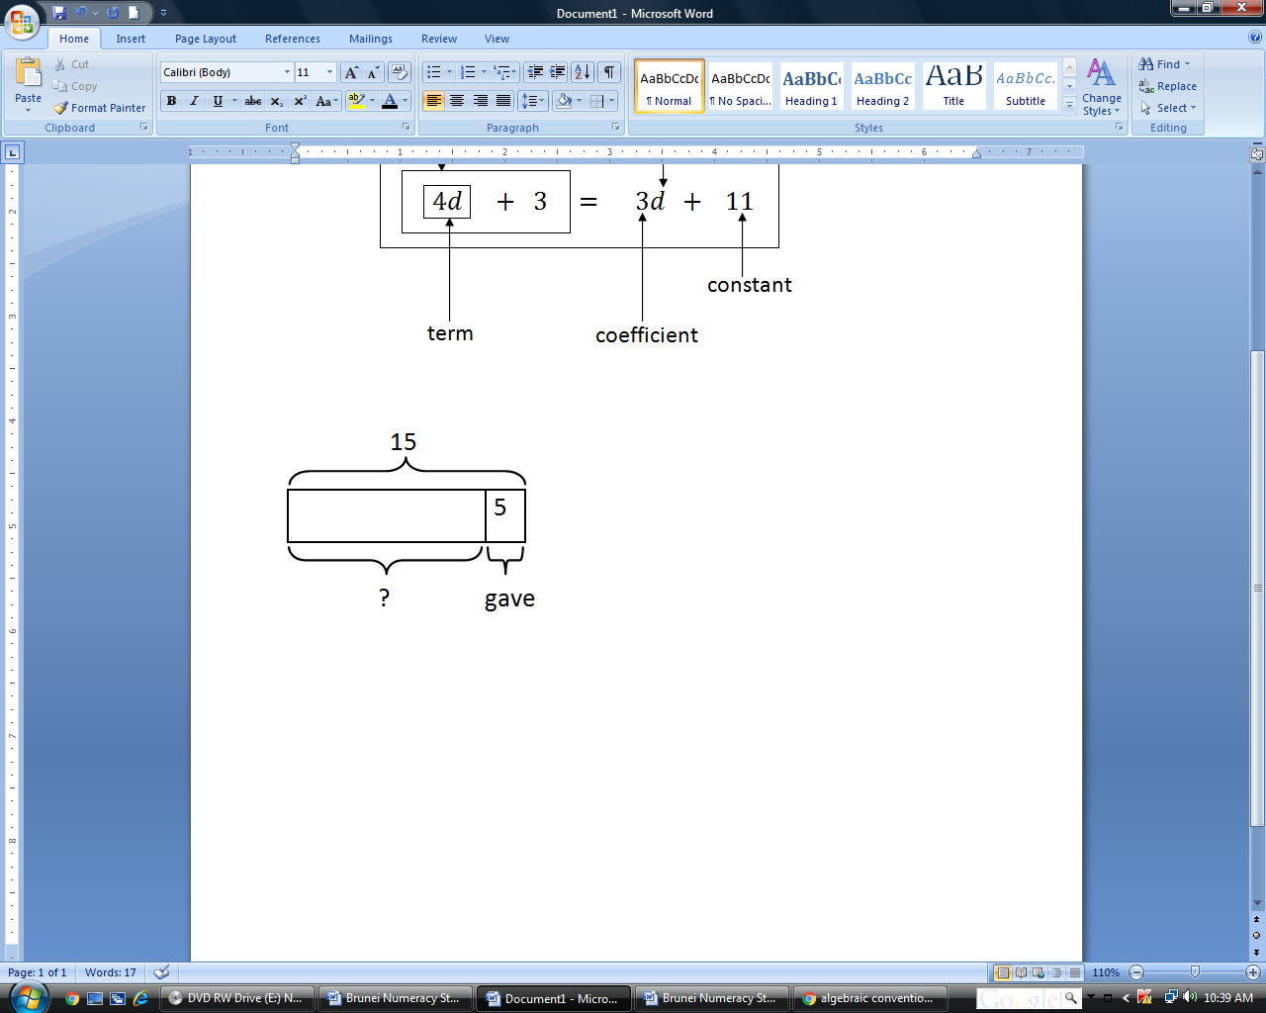 $$15-5$$ Fauzan had 15 cookies left.  - $y$ cookies?  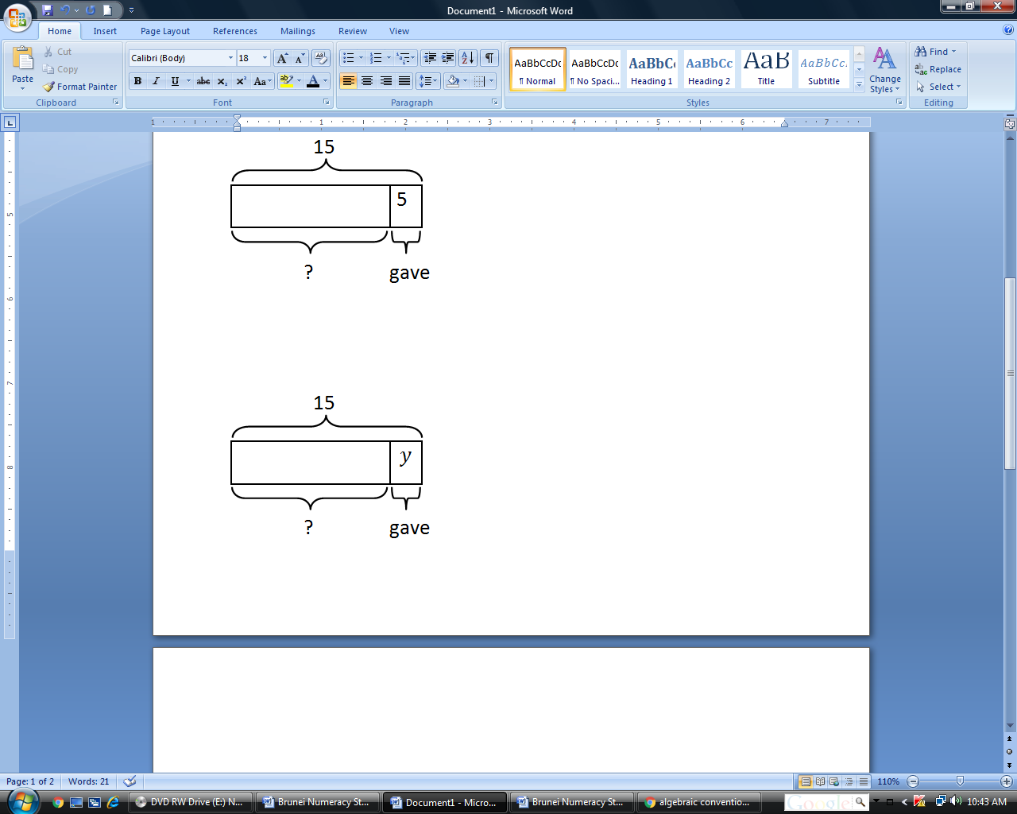 $$15-y$$ Fauzan had $(15-y)$ cookies left.  - Each shirt has 7 buttons. How many buttons are there on different numbers of shirts?  Number of shirts Number of buttons  $$1$$ $$1×7=7$$  $$2$$ $$2×7=14$$  $$5$$ $$5×7=35$$  $$p$$ $$p×7=7p$$  - A pizza cost $18. A cake costs $\$x$ more than a pizza. How much does the cake cost?  - Examples:  Practical Activity  - The figure below shows a rectangle. Find its Perimeter & Area.  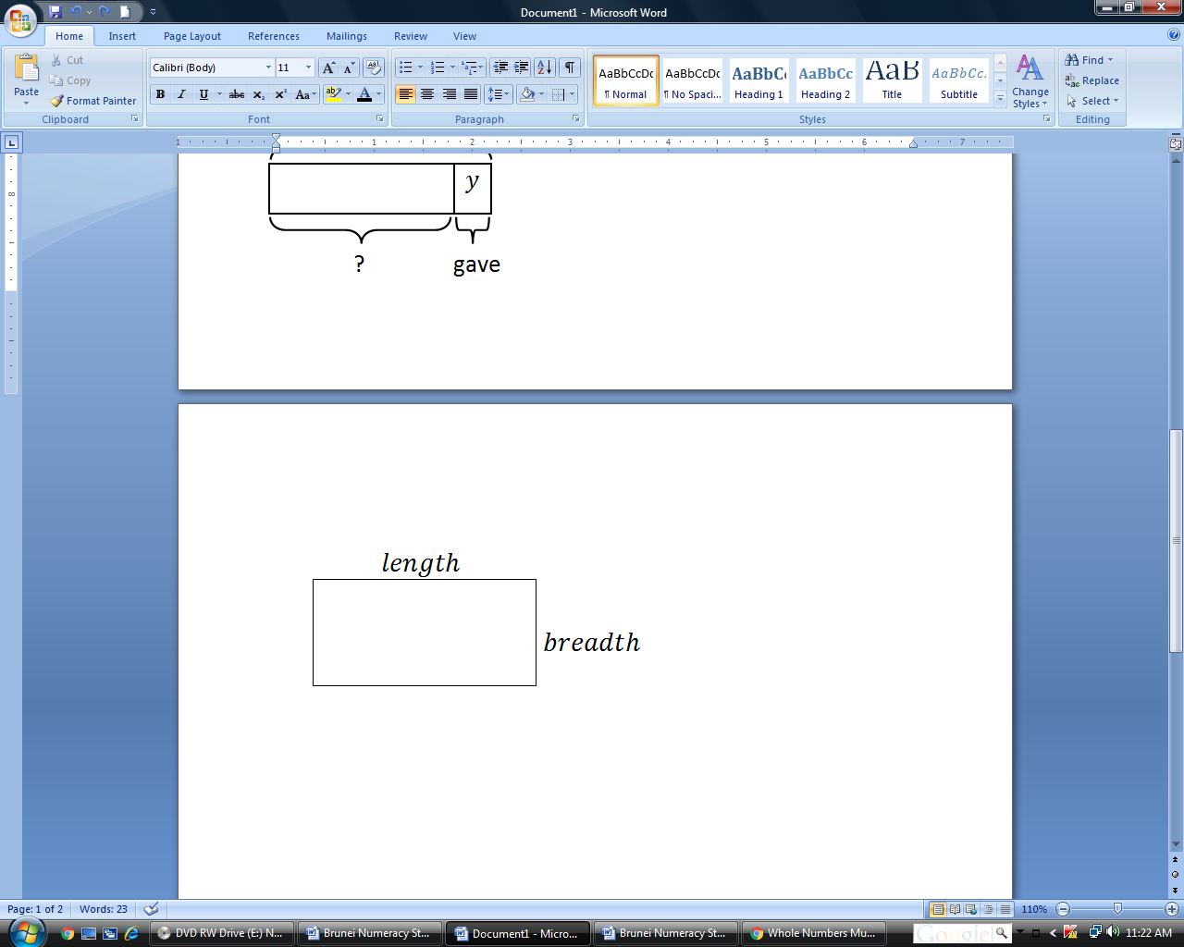  $$length$$ $$breadth$$ $$Perimeter$$ $$Area$$  $$7 cm$$ $$8 cm$$  $$9 cm$$ $$6 cm$$  $$12 cm$$ $$5 cm$$  $$l cm$$ $$b cm$$  - Rayyan save $230 from Hari Raya and birthday gifts. She wants to buy some shirts using her savings. How much money will she have left?  Number of shirt/s Total cost of shirt/s Money left  $$1$$  $$4$$  $$9$$  $$t$$  - Misha had $30. She bought food items which cost $4.50 each. Write an expression which represents the money she had left.  - Alex saves the same amount of money every month for 7 months. At the moment, he has $100 in his savings account. Write down an expression for the total amount of money in his account after 7 months.  - Examples:  - I think of a number, multiply by 2 and then add 3 and I have 11. What is the number?  I can write down this problem as a function machine:  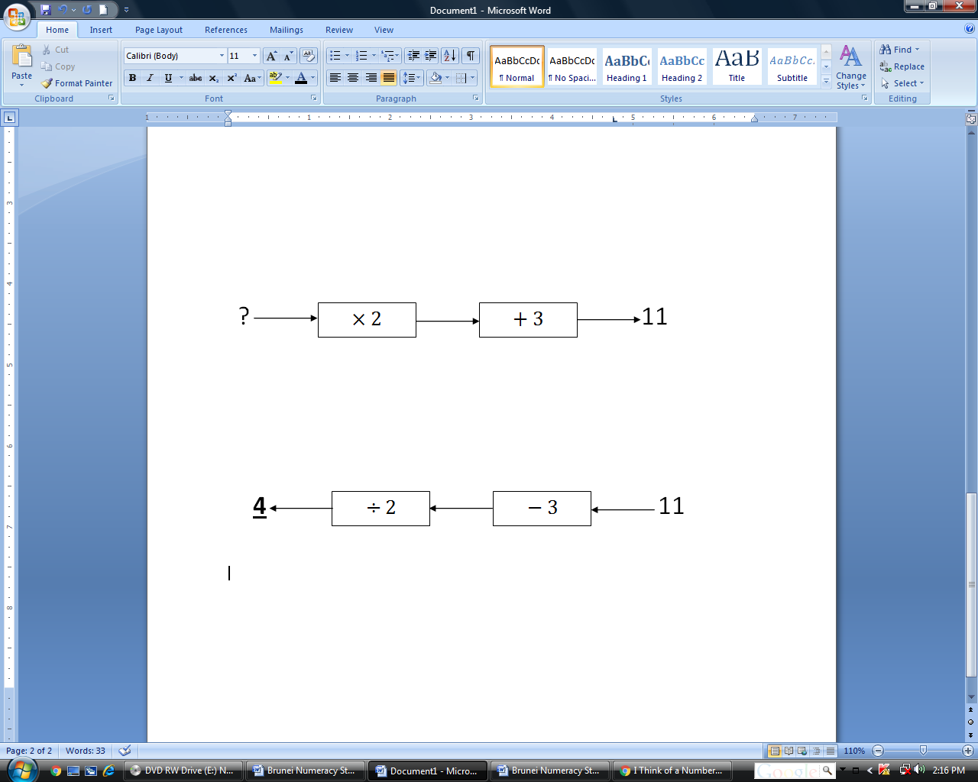  The inverse would be:  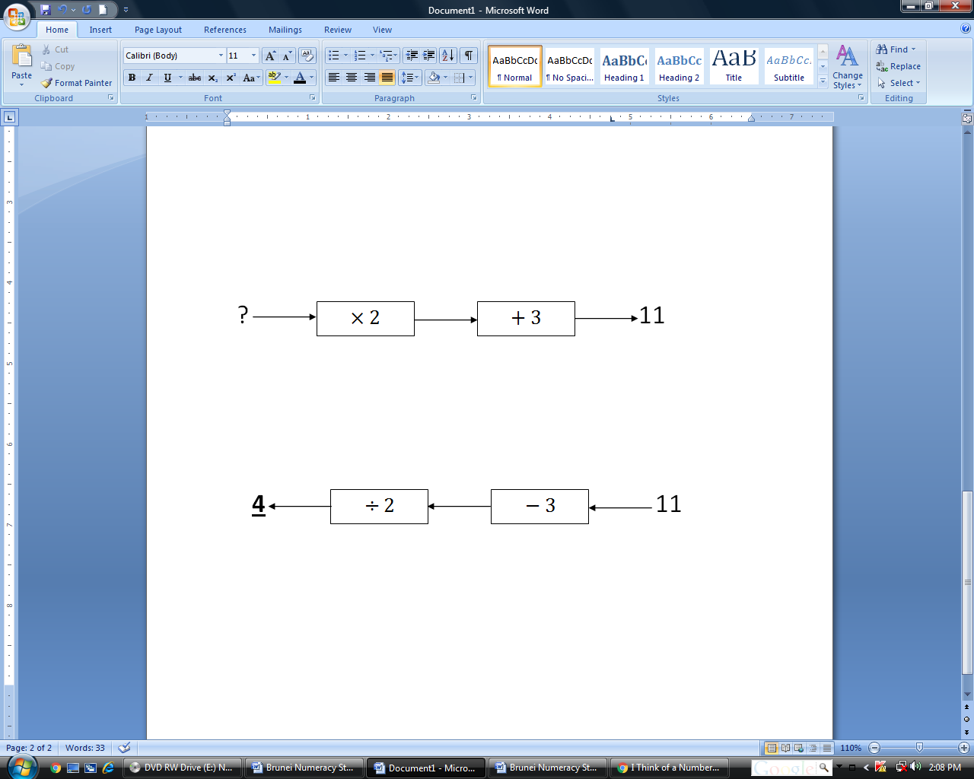  The Inverse helps us solve the problem.  ___ $×2+3=11$  Let the unknown be $a$  $$a ×2+3=11$$  $2a +3=11$ (Linear equation)

SUB-TOPICS | LEARNING OUTCOMES | LEARNING EXPERIENCE/EXEMPLIFICATION | INSTRUCTION TIME
- SIMPLIFYING & TRANSFORMING ALGEBRAIC RELATIONSHIPS  (Link to 1.2.6) | Students should be able to: |  | 2
- Equivalence of algebraic expressions by collecting like terms  - Equivalence of algebraic expressions by multiplying over a bracket  - Equivalence of algebraic expressions by factorising | - Show equivalence (or not) of algebraic expressions by collecting like terms (integer coefficients).  - Show equivalence (or not) of algebraic expressions by multiplying a constant over a bracket (integer coefficients), using models and diagrams.  - Show equivalence (or not) of algebraic expressions by factorising: single-term common factors (e.g. ^{3n}/₃ = n;^{2a}/_{a} = 2). | - Examples:  - Group/pair work  Use cubes, algebra discs or draw diagrams to represent the algebraic expressions. Then simplify the expressions.  - $3g+3g$ - $4g-2g$ - $2g+g+2$  - $4g-4g$ - $6g-3-2g$ - $5g-3g+5-2$  - Identify an equivalent expression.  - 5c - c + c + c - c + c + c + c - c + c + c + c + c - c + c + c + c + c + c - p + p + 0 - 0 - p - 2p - 3p  - 2t + t - t + t - t + 2t - 2t + 2t - t + t + 2 - 2f + 3z - f + z - f + f + z + z + z - 2 ( f + g) - 3 ( f + g)  - Examples:  - Identify an equivalent expression of 4( j + 1)  - j+ 1  - 4j + 1  - j + 4  - 4j + 4  - Expand 4 ( n + 1)  x n 1  4  - Examples:  Factorise:  - $\frac{5a}{5}$ - $\frac{yz}{y}$ - $\frac{-10gh}{2j}$

SUB-TOPICS | LEARNING OUTCOMES | LEARNING EXPERIENCE/EXEMPLIFICATION | INSTRUCTION TIME
- SOLVING LINEAR EQUATIONS  (Link to 1.2.6) | Students should be able to: |  | 2
1.8.1 Evaluating simple algebraic linear expressions  1.8.2 Solving simple linear equations  1.8.3 Solving word problems | - Evaluate simple algebraic linear expressions arising from practical contexts, including mathematical and scientific formulae, by substitution (positive integers).  - Solve ‘Think of a number’ type problems, using an appropriate method (e.g. ‘seeing’, doing the inverse).  Solve simple linear equations (integer coefficients and constants, unknown on one side only) arising from practical situations using an appropriate method (e.g.‘seeing’, inverse operations, trial and improvement).  Check solutions to equations by substitution.  - Solve word problems that involve constructing and solving simple linear algebraic expressions and equations. | - Examples:  - Given that $P=2l+2w$, where $P$ is the Perimeter of a rectangle, $l$ is its length and $w$ is its width. Find the Perimeter of a rectangle when $l=9 cm$ and $w=5 cm$.  - Given the formula $m=v ×d$, where $m$ is mass, $v$ is volume and $d$ is density. Find the volume in g, given $m$ = 60 g and $d$ = 2 g/${cm}^{3}$.  - Mrs Zariah spent $\$C$ to buy $x$ calculators and $y$ pencils. A calculator costs $\$18$ and a book costs $\$10.$  - Find an algebraic expression for calculating $\$C$.  - Find $C$ if $x=5$ and $y=10$  - Example:  I think of a number, multiply by 2 and then add 3 and I have 11. What is the number?  I can write down this problem as a function machine:    The inverse would be:    The Inverse helps us solve the problem.  $$x ×2+3=11$$  $$x=(11-3) ÷2$$  $$x=8 ÷2$$  $$x=4$$  - Check solutions to equations by substitution.  When $x=4, x ×2+3=4 ×2+3=8+3=11=$ RHS  Therefore, the solution $x=4$ is correct.  - Solve word problems that involve constructing and solving simple linear algebraic expressions and equations. Examples:  - I think of a number. When I add 3 to that number, the result is 10. What is that number?  - I think of two numbers. The product of the two numbers is 60. What are my numbers?  - The perimeter of a rectangle is 24 cm. Its length and width are given in whole units (such as 2 cm, 5 cm, etc.) Draw all the possible rectangles.  - Ahmad has $x. Abu has $5 more than Ahmad. Razak has twice as much as Abu. Together they have $175. What is the value of x? YR8?  - Ahmad had 40 kg of rice. He gave some rice to his uncle. He had 27 kg of rice left. How many kilograms of rice did he give to his uncle?  - Sofian has some money. Siti has $20 more than two times Sofian’s money. If Siti has $68, how much money does Sofian have? YR8?  - My weight is x kg. Hassan’s weight is 30 kg. If our total weight is 55 kg, what is my weight?  - The cost of a fan is $8t. A lamp costs $\frac{1}{2}$ more than that of a fan. What is the total cost of the fan and the lamp?  - Number Sense Quizzes (No calculators!)  - Consecutive whole numbers are numbers next to one another. For example, 34 and 35 are consecutive numbers, and their sum is 69. Using your mental computation methods, find the two consecutive numbers that have a sum of:  - 71 (b) 201 (c) 567  - Using your mental computation methods, find the three consecutive numbers that have a sum of:  - 6 (b) 24 (c) 117

SUB-TOPICS | LEARNING OUTCOMES | LEARNING EXPERIENCE/EXEMPLIFICATION | INSTRUCTION TIME
1.9 PROPERTIES OF NUMBERS & SEQUENCES | Students should be able to: |  | 1
1.9.1 Triangle numbers  1.9.2 Linear patterns & integers sequence.  1.9.3 Generating terms of a sequence  1.9.4Generating sequences from practical context | d) Understand and recognise the sequence of triangle numbers.  e) Describe and continue linear growing patterns and sequences of integers.  - Generate terms of a sequence given a simple rule (term-to-term and general term).  - Generate sequences from practical contexts and describe the general term using words, mapping diagrams and symbols. | - The sequence of triangle numbers:  This sequence comes from a pattern of dots that form a triangle.  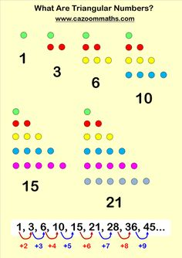  Diagram (n) No. of dots Sequence rule (n-1)+n  1 1 1  2 3 1+2  3 6 1+2+3  4 10 1+2+3+4  5 15 1+2+3+4+5  6 21 1+2+3+4+5+6  - A linear growing pattern/sequence is a pattern/a series of numbers that increases or decreases by a constant difference.  - Examples:  - State the rule of each of the following number patterns and write down the next two terms.  - 2 , 4 , 6 , ____ , ____  - 1 , 4 , 9 , 16 , ____ , ____  - 0 , 1 , 1 , 2 , 3 , 5 , ____ , ____  - Fill in the missing numbers.  - 8 , ____ , ____ , -4 , -8 , -12  - 16 , 48 , 24 , ____ , ____ , 108 , 54  - Write down the 7th and 10th terms of the number patterns. Use a calculator to check your answers.  - 13 , 18 , 23 , 28 , ...  - 200 , 140 , 80 , 20 , ...  - Examples:  - Generate a number sequence using the rule “Add 3”. Start at zero.  - The numbers in the sequence 7, 11, 15, 19, 23, … increase by four. The numbers in the sequence 1, 10, 19, 28, 37, … increase by nine. The number 19 is in both sequences. If the two sequences are continued, what is the next number that is in BOTH the first and the second sequences?  - Examples:  - Look at the growing pattern below:  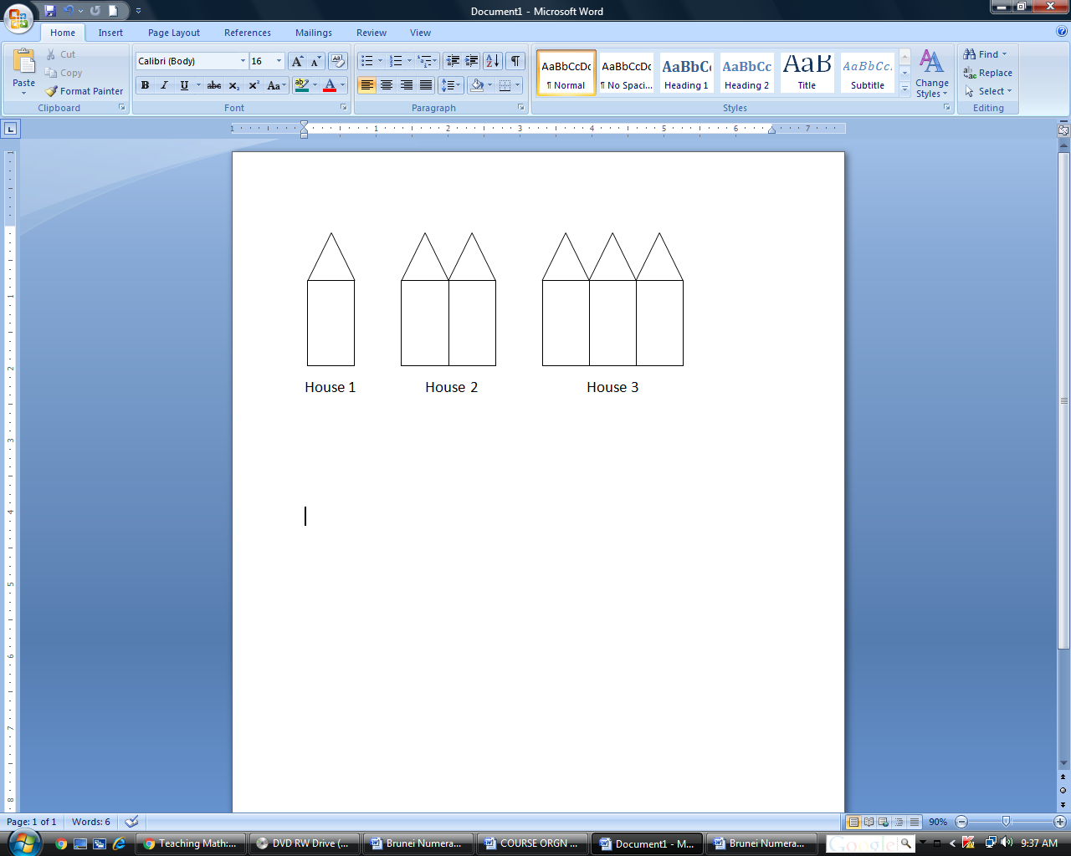  - What do you notice about these houses?  - What do you think the fourth house will look like? Show how it looks like.  - Describe House 5. Write the rule pattern and the fifth terms for  - Number of triangles  - Number of rectangles  - Total number of all the shapes  - How will House 20 look like?  - Describe House 100.  - Which house has 12 triangles and 12 rectangles?  - Study the pattern below.  - Draw Pattern 5.  - Pattern 2 has 9 corners, how many corners will there be in Pattern 8?  - Pattern X has a total of 36 corners. Find X.

SUB-TOPICS | LEARNING OUTCOMES | LEARNING EXPERIENCE/EXEMPLIFICATION | INSTRUCTION TIME
1.10 RELATIONSHIPS & GRAPHS | Students should be able to: |  | 2
1.10.1 Expressing linear relationships algebraically, in tables & graphically  1.10.2 Plotting simple linear functions graphs  1.10.3 Plotting & interpreting simple linear real-life situations graphs | a) Understand that linear relationships can be expressed in different ways: algebraically; in tables; graphically.  b) Generate coordinate pairs that satisfy a simple linear rule using function machines, function tables and algebraic expressions.  c) Use conventions and notation for 2D coordinates in all four quadrants to solve problems.  - Plot the graphs of simple linear functions (first quadrant), where y is given explicitly in terms of x.  - Plot and interpret the graphs of simple linear functions arising from real-life situations.  *Related to 3.1.3 Line graphs (Data Analysis)* | Examples:  1. Draw the next three diagram patterns.  Diagram 1 Diagram 2 Diagram 3 Diagram 4  Describe the diagram pattern in words : The number of rectangle increase by 1 or add 1 more rectangle.  Complete the table by filling in the blanks.  Diagram no. 1 2 3 4 5 6 7  No. of rectangle 2 3 4 5  Diagram no. No. of rectangle  Term (x) Value (y)  1 2 3 4 5 6 7 2 3 4 5  Plot the next three points in the graph below.  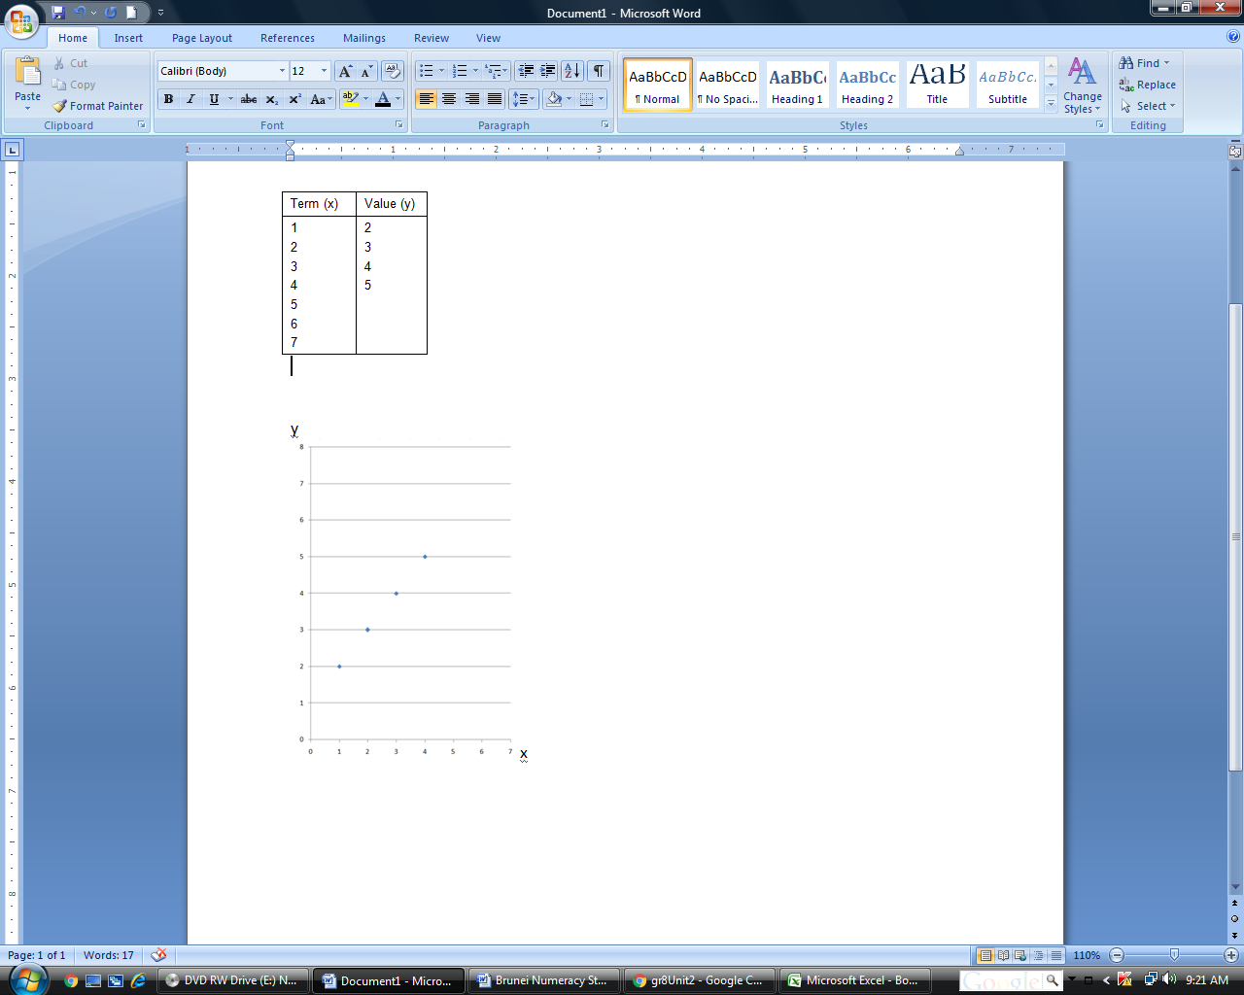  No. of rectangle  Diagram no.  This shows how linear relationships can be expressed algebraically; in tables; and graphically.  - Guide students to calculate coordinates of points (coordinate pairs) based on given equations of straight lines. Provide a table to record the ordered pairs. Guide them to plot and draw the graphs, using 1 cm scale on both axes.  - Example:  - Generate coordinate pairs by completing the following table of values for the equation y = x + 4.  x 0 2 3 5  y  - Plot the points in a grid and obtain the straight line graph of y = x + 4.  - From your graph, find the value of  - y if x = 4  - x if y = 5  Guide students to:  - calculate the values of y based on given values of x  - prepare a coordinate plane on graph paper using the scale of 1 cm to represent 1 unit on both axes (or suitable scales)  - plot the points  - draw the straight line graph  - Ana is 5 years older than her brother. Her brother is x years old.  Write an expression for Ana’s age.  Let Ana’s brother be x  Algebraically, therefore Ana is (x + 5) years old.  If x = 3, then Ana is (3 + 5) = 8, (by substitution).  If Ana’s brother is 10 years old, then Ana is 15 years old.  In tables,  Ana’s brother x 2 3 10  Ana x + 5 7 8 15  Graphically,  Ana (x + 5)  Ana’s brother (x)  Then, introducing the above linear line as having the equation y = x + 5.  - Instruct students to interpret ready graphs and find answers to questions.  - Examples:  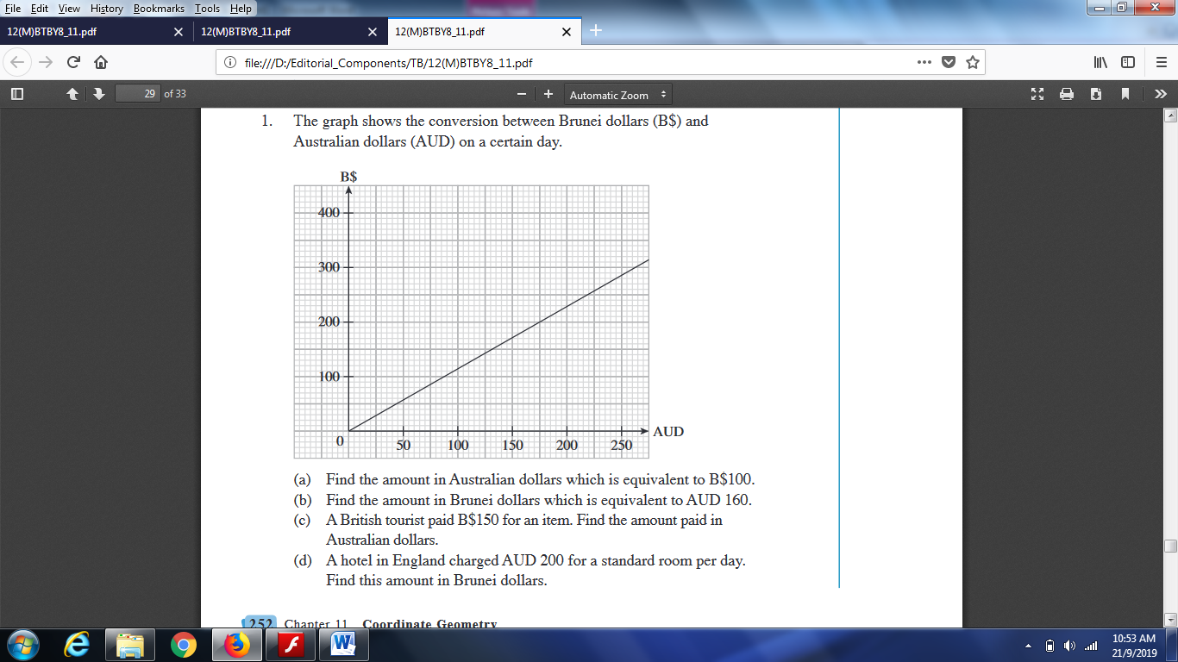  2.  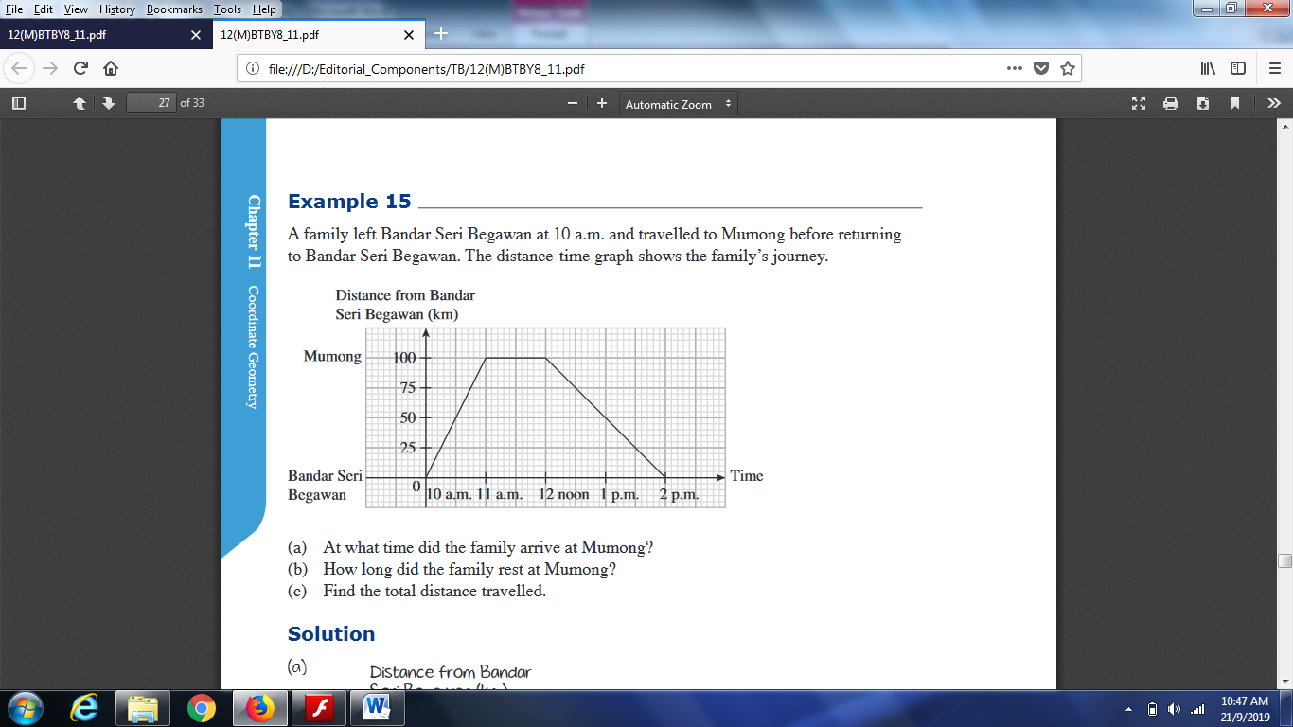  - Plot and interpret simple linear functions graphs from real-life situations.  Example:  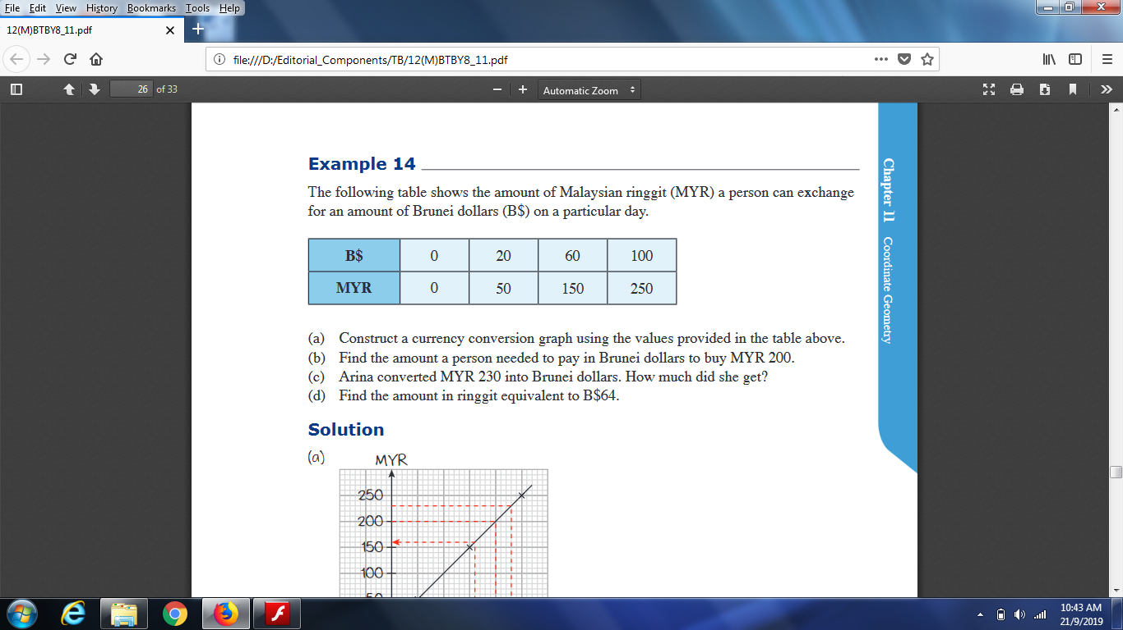

2. MEASUREMENT & GEOMETRY (6 WEEKS)
SUB-TOPICS | LEARNING OUTCOMES | LEARNING EXPERIENCE/EXEMPLIFICATION | INSTRUCTION TIME
2.1 TIME, PERIMETER, AREA, & VOLUME | Students should be able to: |  | 2
- Time  - Perimeter & Area of plane figures  - Perimeter & Area of polygons  - Circumference of a circle  - Nets of cuboids, triangular prisms, regular tetrahedra, square-based.  - Volume of cuboids and simple composite solids. | - Read the time on analogue and digital clocks and solve problems involving units of time, including start times, end times and duration of events.  Understand and use 12-hour clock and 24-hour clock notation.  Solve problems involving timetables.  b) Solve problems that involve calculating the perimeter and area of plane figures: rectangles (including squares), triangles, parallelograms (including rhombuses) and trapeziums.  c) Solve problems that involve calculating the perimeter and area of polygons that can be split into rectangles and triangles.  d) Understand and use correctly the vocabulary for parts of a circle: centre, radius, diameter, circumference, arc, chord, sector.  e) Construct a circle given: its centre and radius; its centre and a point on the circumference.  - Understand $π$ as the ratio of circumference to diameter of a circle.  Understand and use the formulae C = $π$d or C = 2$π$r to solve problems involving circumference, diameter and radii of circles.  - Identify and draw nets of cuboids, triangular prisms, regular tetrahedra, square-based pyramids.  - Solve problems that involve calculating the volume of cuboids (including cubes) and simple composite solids made from cuboids. | Examples:  $$A$$  $$B$$  $$C$$  $$5x$$  $$15-x$$  $$2x+12$$  - Convert 1.3 hours to minutes.  - Convert 150 minutes to hour.  - Convert 3.30 pm into 24-hour clock notation.  - A movie starts at 6.45 pm. It lasts 2 hours and 35 minutes. What time will the movie finish?  - It takes 1 h 5 min for Bob to travel from home to his office. If he wants to reach the office by 8.30 a.m. what time should he leave his house?  - These are the start and finish times of a DVD recorder:  START 14:45  FINISH 17:25  For how long was the DVD recording?  - An aeroplane takes off on Tuesday at 22:47. It lands on Wednesday at 07:05. How long in hours and minutes is the flight?  - These are the times letters are collected from a post box.  Monday to Friday Saturday Sunday  8 am 2 pm 6:30 pm 11:30 am No collection  - What is the latest time letters are collected on Wednesday?  - Anna posts a letter at 9 am on Monday. How long will it be before it is collected?  - Shafi posts a letter on Saturday at 3 pm. When is it collected from the post box?  Day: _______  Time: ________  - Hu Yen is comparing the duration she spends at dance practice each day. She thinks she spends the greatest duration dancing on Tuesday and the least duration dancing on Wednesday. Do you agree with Hu Yen’s thinking? Explain.  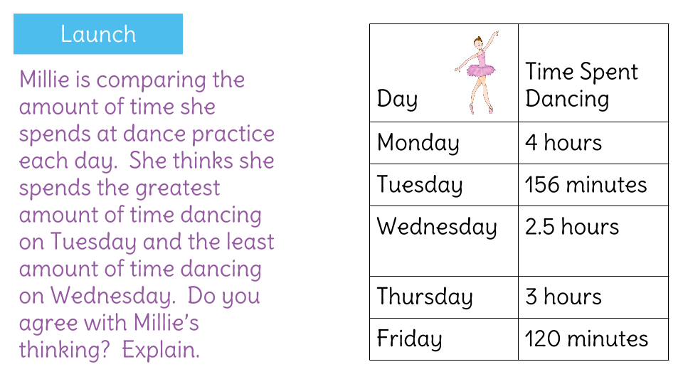  - Rahman, Mateen and Hanan run a 50m race.  Mateen’s time is 13 seconds.  Rahman finishes 5 seconds before Mateen.  Hanan finishes 3 seconds after Rahman.  What is Hanan’s time in seconds?  - One of these watches is 3 minutes fast. The other watch is 4 minutes slow. What is the correct time?  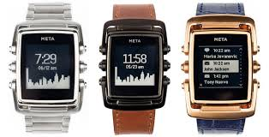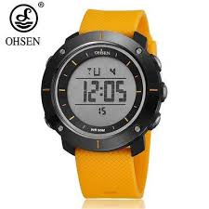  - Examples:  - The perimeter of a square is 20 cm. Find the length of each of its sides.  - The perimeter of a rectangle is 36 cm. If each length is 12 cm, what is the size of each of its width?  - The figure below is made up of 2 identical squares. The total area of the figure is 50 cm². Find the value of k and m.  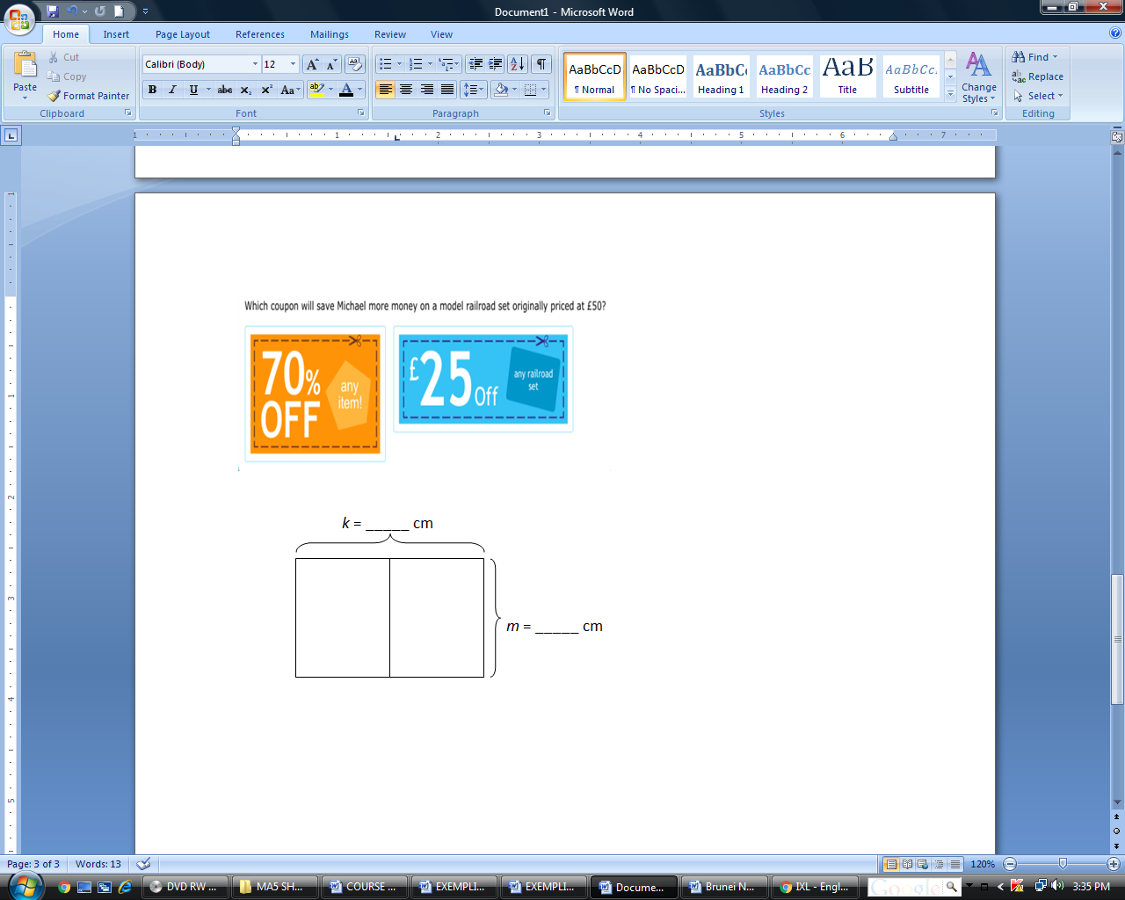  - Do triangles with the same base and height have the same area?  - What happens to the area of a triangle when its height is increased?  - The lengths of the sides of triangle $ABC$ are 5$x$ , $\left(15-x\right)$ and $(2x+12)$.  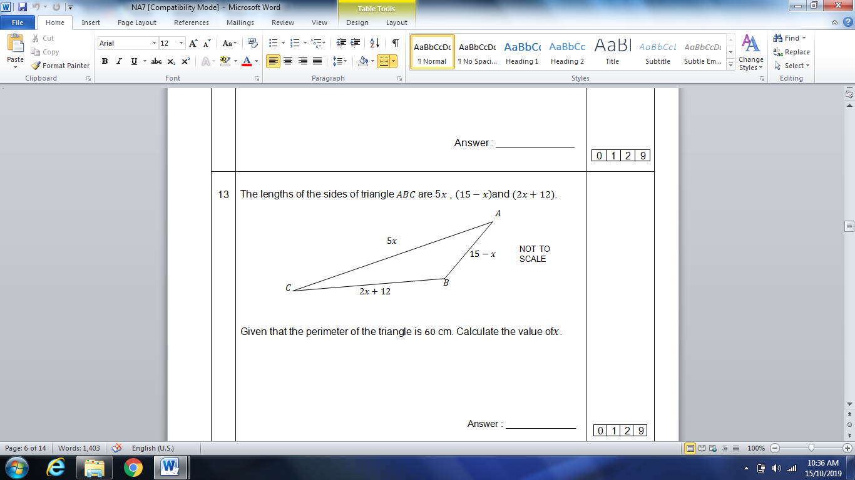  Given that the perimeter of the triangle is $60 \text{cm}$.  Calculate the value of$x$.  - The figure consists of 5 squares of equal area. The area of the whole figure is 180 ${cm}^{2}$. Find the perimeter of the figure.  - In the figure, D and E are squares and F is a right-angled triangle. The areas of D and E are 9 cm² and 16 cm² respectively. What is the area of F?  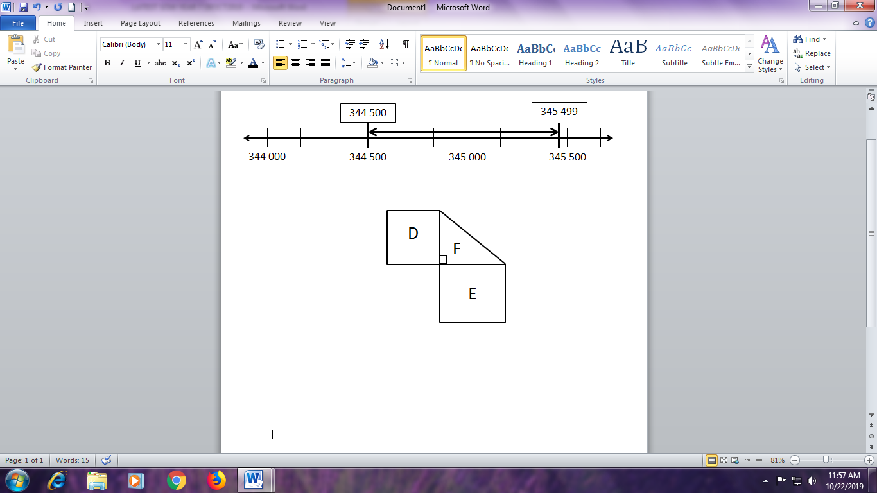  - Examples:  - Find the perimeter and area of the figure:  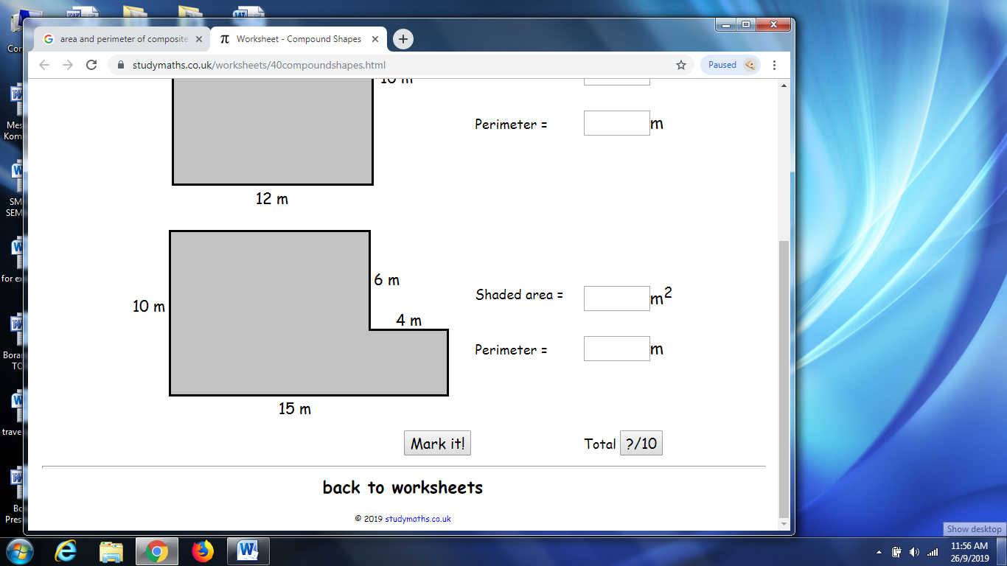  - Find the area of the figure:  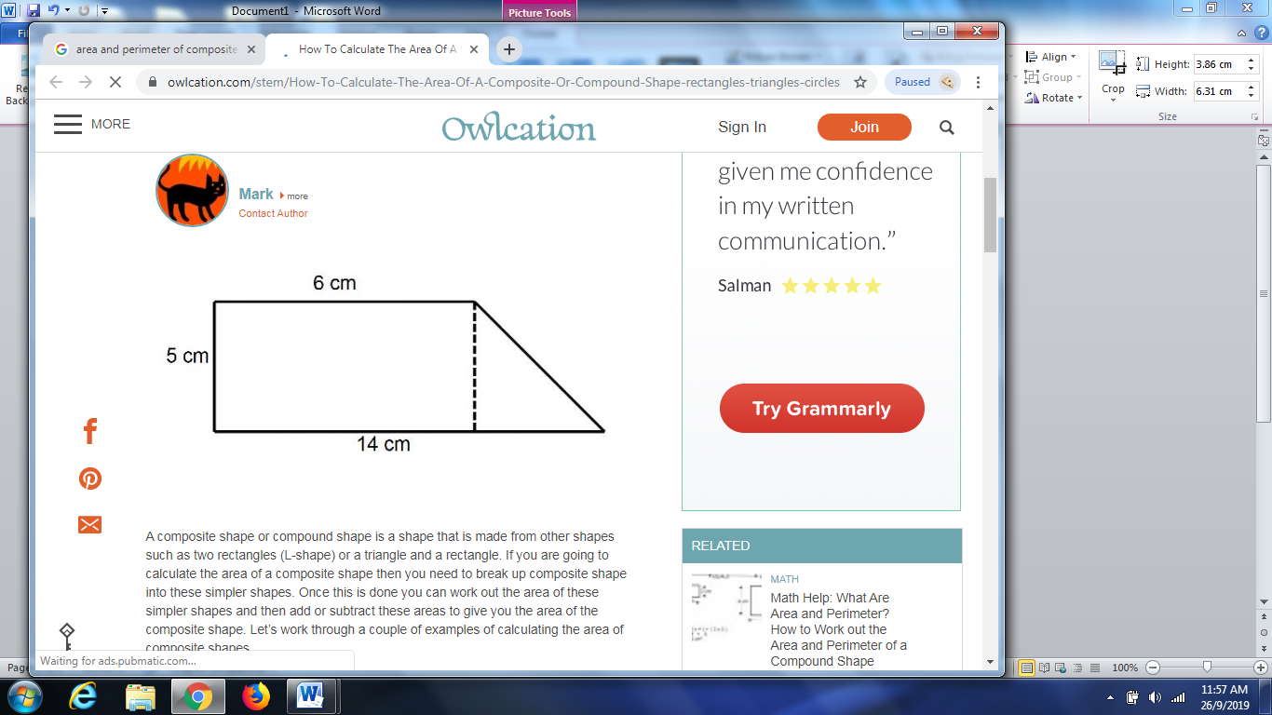  - Give clear instructions on the use of the compasses, especially with regards to measuring the radius, and fixing the centre before drawing the circle. Guide students to draw a few circles as practice.  - Label on the 1st circle: circumference, centre, radius and diameter.  - Label on the 2nd circle: arcs (major arc and minor arc), sectors (major sector and minor sector). Shade the sectors in different shadings.  - Label on the 3rd circle: chord, angle subtended at the centre by the chord, major segment and minor segment.  - Construct a circle using a pair of compasses.  - Examples:  - Construct a circle with radius 4 cm and center O.  - Construct a circle with diameter 6 cm and center A.  - Establish the formula for circumference of a circle through an investigative activity. Calculators should be used.  Step 1: Preparation  - Prepare cardboard cut-outs of circular discs of varying radii, e.g., 4cm, 5cm, 8cm, etc. Mark centers of discs with small dots.  - Provide thin strings to ‘run around’ the edges of the discs and read off the lengths of circumference on a ruler.  - Provide a format for recording circumferences (C) and diameters (d) and to guide investigation into the ratio C/d.  Circle Radius (r) Circumference (C) Diameter (d) C/r  1  2  Step 2: Investigation by students  - Randomly provide 2 – 4 circular discs to each pair of students.  - Give instructions to guide investigation:  - Measure the radius of each circle. Record your measurement.  - Wind the string around the disc and measure the length of string which goes one full circle around the disc. Record your measurement in the column called circumference.  - Complete the column diameter.  - Use your calculator to compute the ratio C/d and record it in the table.  - What do you observe in the results under the column? How are C and d related?  - Consolidate all students’ findings and introduce this ratio as π (pi). Guide students to derive the formula: C = π x d, where d = diameter.  - Explain that C = 2πr, where r = radius, since d = 2r.  - Apply the relationship to find the circumferences of two more circles.  - Solve problems involving circumference, diameter and radii of circles.  Examples:  - The diameter of a circle is 14 cm. What is the length of its radius?  - Calculate the perimeter of a circle with radius 5 cm. Give your answers in terms of π.  - The circumference of a circle is 44 cm. What is the length of its radius?  - Review nets of cuboids.  - Use concrete models of cuboids, triangular prisms, regular tetrahedra, square-based pyramids and to help students visualise 3-dimensional figures and draw nets of these solids.  - Guide students to identify the length, the breadth and the height of a cuboid in 3-dimensional figures.  Length  Breadth  Height  Cross Section  - Guide students to derive the formula of volume of a cuboid:  Volume of cuboid = l x b x h  = b x h x l  = area of cross section x length  Examples:  - Find the volume of a cube whose side is 4 cm.  - The volume of a cube is 27 cm³. What is the length of each of its sides?  - The volume of a cube is 8 cm³. What is the area of each of its faces?  - Find the volume of the solids:  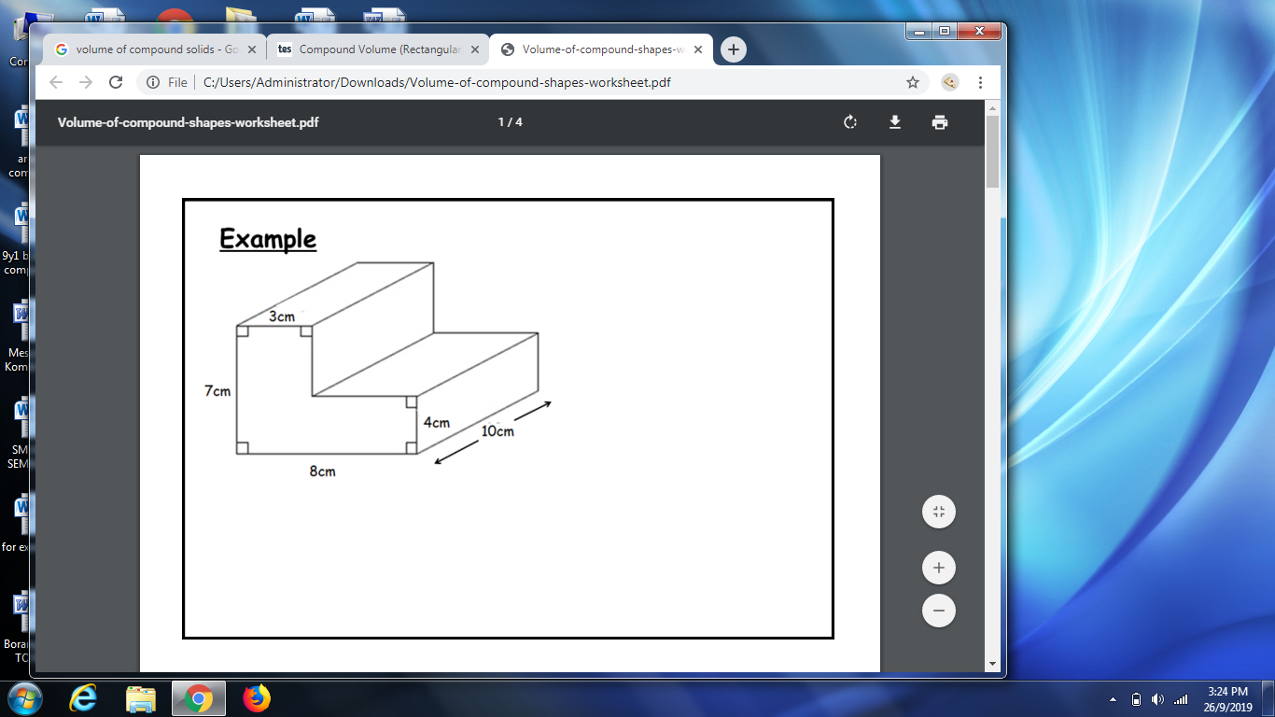 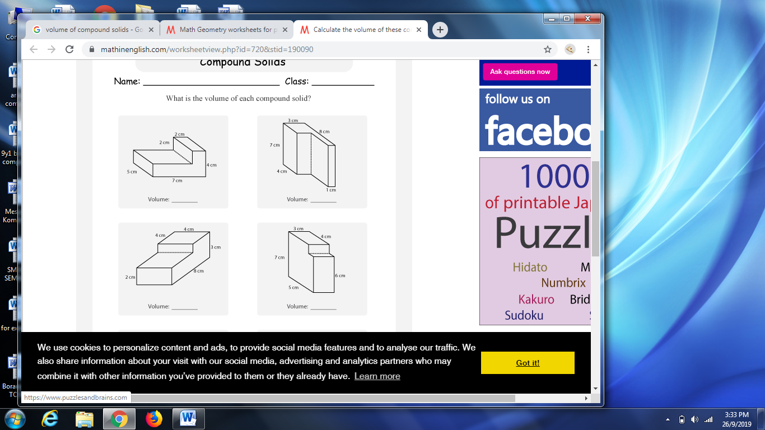

SUB-TOPICS | LEARNING OUTCOMES | LEARNING EXPERIENCE/EXEMPLIFICATION | INSTRUCTION TIME
2.2 SYMMETRY & TRANSFORMATIONS | Students should be able to: |  | 2
- Lines of symmetry & Reflection  - Rotational symmetry & Rotation  - Translation | - Understand and use the language and notation associated with reflections, rotations and translations.  - Recognise, visualise and identify lines of symmetry.  Reflect plane shapes in horizontal, vertical and diagonal mirror lines, including on a coordinate grid (all four quadrants).  - Recognise, visualise and identify 2D rotational symmetry and identify centres of rotation.  Rotate polygons on a coordinate grid (all four quadrants) after a rotation of 90º or 180º clockwise and anti-clockwise around one of its vertices.  - Recognise and visualise 2D translations.  Translate a polygon on a coordinate grid (all four quadrants). | - Give general ideas about the topic ‘TRANSFORMATION’ by showing examples of reflection, rotation and translation.  - Discuss the significance of using transformations in designing works (Escher patterns and Islamic geometrical patterns).  - Review the idea of line symmetry through paper folding of cut-outs of any shapes and using a plane mirror to show the mirror image of an object.  - Explain line symmetry of figures and introduce the term ‘axis of symmetry’ or ‘line of symmetry’.  - Line symmetry, mirror symmetry, mirror-image symmetry, reflection symmetry, is symmetry with respect to reflection.  - Guide students to draw the line of symmetry of a given figure and to complete a symmetrical figure drawing.  Examples of practical activity:  - Stand a plane mirror in front of an object to introduce the idea of reflection. Position the mirror behind a picture lying on a table top and ask students to observe the image of the picture in it.  - Show pictures which illustrate objects and images and their mirror lines.  - Explain the terms ‘object’ and ‘image’ with reference to the pictures and the mirror demonstrations.  - Emphasise that in any reflection, there is a ‘mirror line’ which separate the object from the image. Guide students to identify the mirror lines in such pictures and drawings.  - Guide students to recognise that the perpendicular distance of the image point from the mirror line (or axis of reflection) is equal to the perpendicular distance of the object point from the mirror line.  - Guide students to perform reflection on given figures in given (i) vertical mirror lines, (ii) horizontal mirror lines and (iii) diagonal lines (45⁰ to the horizontal).  - Provide practices on drawing the reflection images of given figures on a coordinate grid (all four quadrants).  - Guide students to note the invariant properties (angles and sides) of an object and its image under a reflection. Such properties will be used to check accuracy of images and will not be applied in problems.  Examples:  - Reflect the figure A in the given mirror line and label the image as figure B. [Discuss the technique to draw the image.]  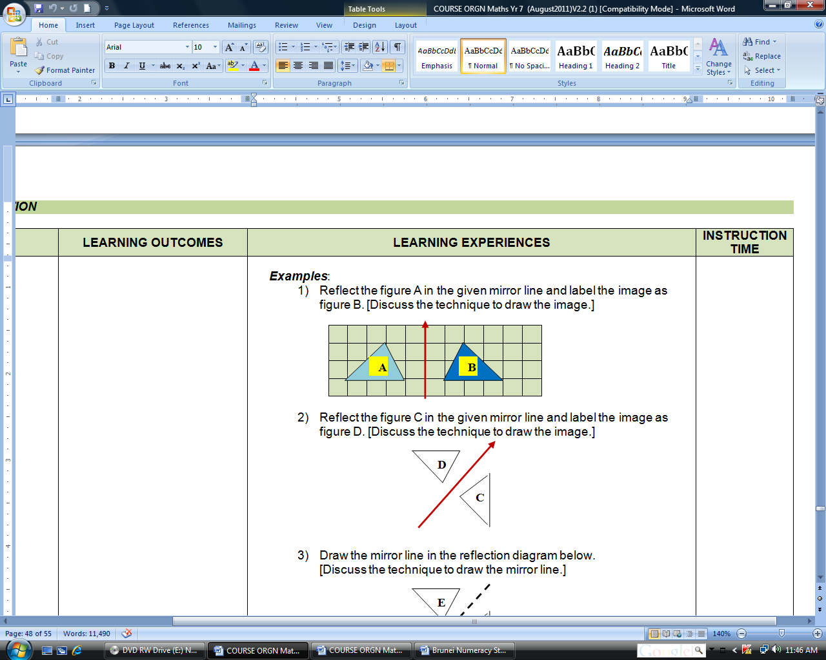  - The diagram shows quadrilateral PQRS on a grid. MN is the axis of reflection. Draw its image $P_{1}Q_{1}R_{1}S_{1}$.  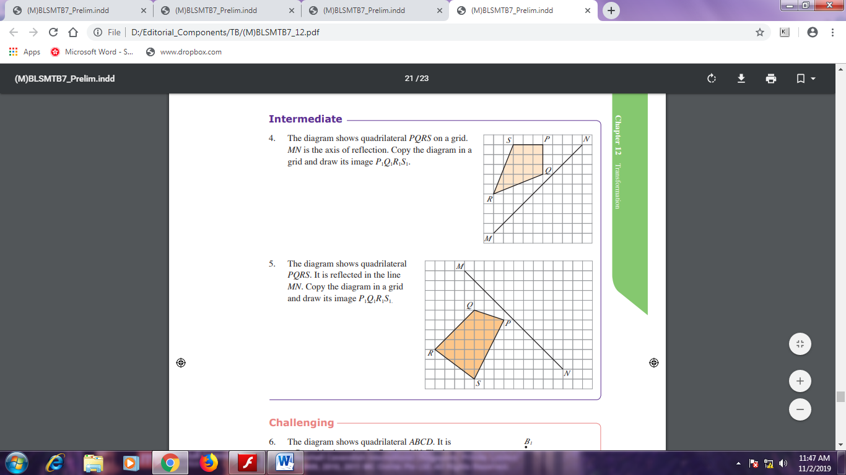  - The diagram shows quadrilateral PQRS. It is reflected in the line MN. Draw its image $P_{1}Q_{1}R_{1}S_{1}$.    - Introduce the idea of rotational symmetry using different figures.  - Show a cut out figure with a pin and rotate it about the pin.  - Emphasise that there must be a centre of rotation in a figure with rotational symmetry.  - Examples:  Rotate the shapes 90$°$ and 180$°$ clockwise/anti-clockwise about the point A.  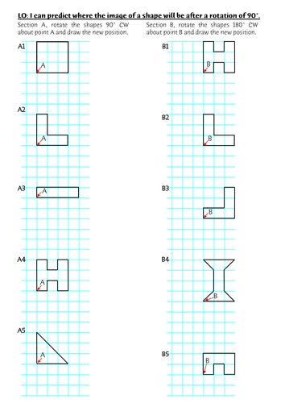    - Introduce the first idea of translation by shifting  a piece on a chess board in a specified direction.  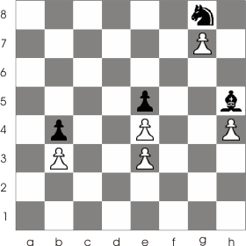  Examples:  - Shifting a queen 2 steps to the right  - Shifting a pawn 1 step forward  - Shifting a knight 3 steps to the left and 2 steps forward  - Demonstrate the translation of a given figure drawn in a coordinate plane point (object point) by a specified number of steps horizontally and vertically in the coordinate plane. Label the image (image point)  Examples:  - Translate the Figure A by a shift of “5 steps to the left and 2 steps up”. Label the image as Figure B.  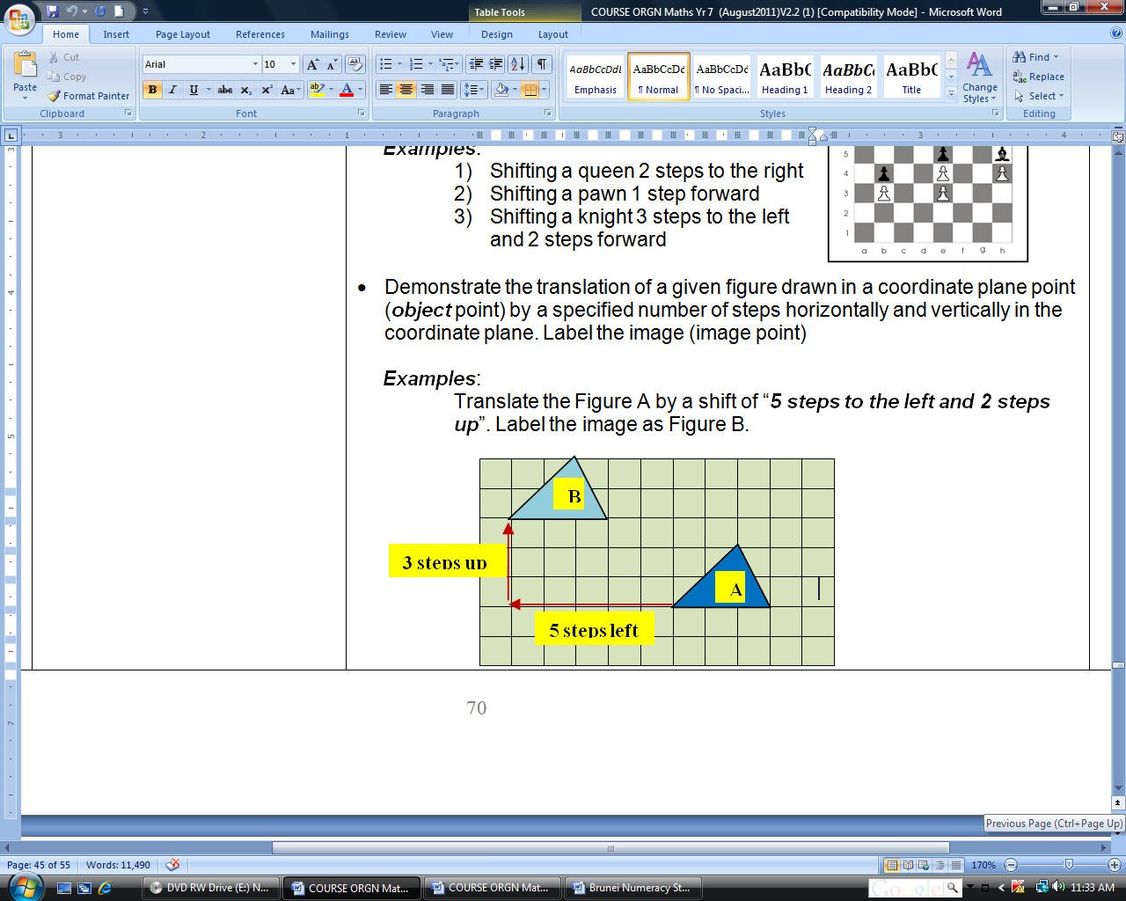  - Translate triangle PQR 6 units to the left and 4 units up. Draw and label the image $P_{1}Q_{1}R_{1}$.  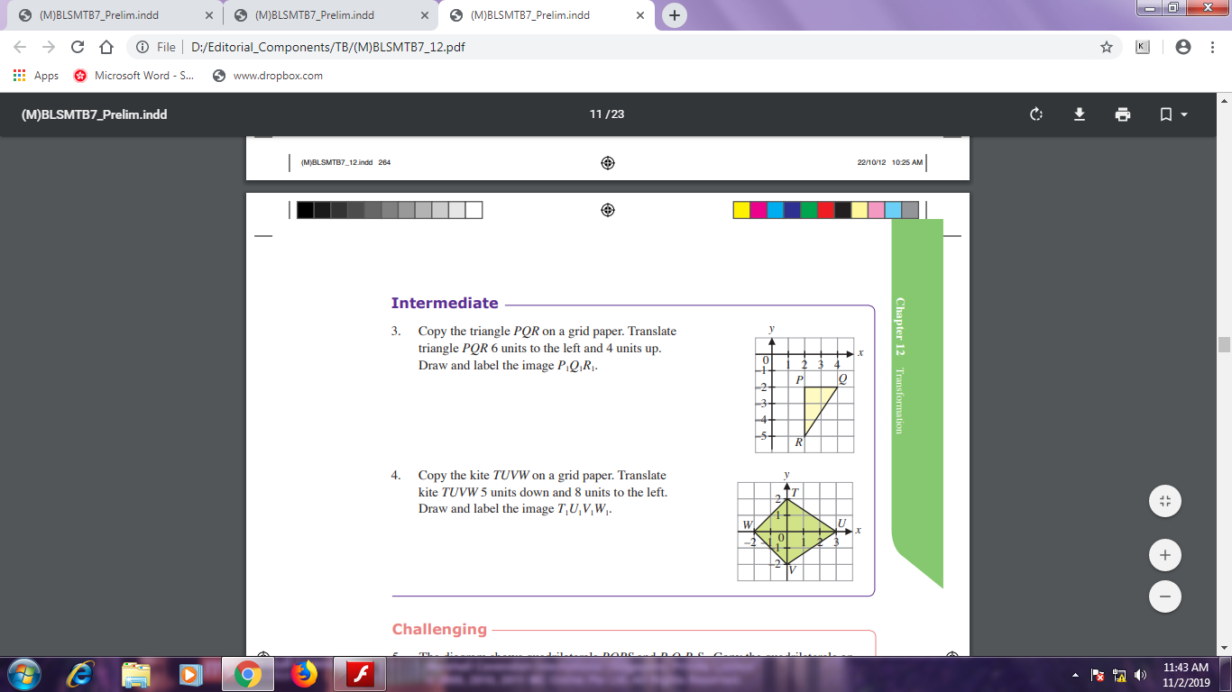  - Translate kite TUVW 5 units down and 8 units to the left. Draw and label the image $T_{1}U_{1}V_{1}W_{1}$.    - Guide students to note the invariant properties (angles and sides) of an object and its image under a translation. Such properties will be used to check accuracy of images and will not be applied in problems.

SUB-TOPICS | LEARNING OUTCOMES | LEARNING EXPERIENCE/EXEMPLIFICATION | INSTRUCTION TIME
2.3 PLANE & SOLID SHAPES | Students should be able to: |  | 2
- Lines, angles, plane & solid shapes.  - Properties of angles: angles on a straight line, angles around a point & vertically opposite angles.  - Triangles. | a) Understand and use correctly the vocabulary, notation and labelling conventions for lines, angles, plane and solid shapes.  b) Use a protractor to measure and draw angles, including reflex angles, to the nearest degree.  c) Solve problems involving angles on a straight line, angles around a point and vertically opposite angles.  - Solve geometrical problems involving line, angle and symmetry properties of equilateral, isosceles and right-angled triangles, including finding unknown angles.  Explain geometrical reasoning using diagrams and words.  - Use a ruler and protractor to construct a triangle given two sides and the included angle (SAS) or two angles and the included side (ASA). | - Demonstrate rotation using a hand-held fan and discuss the need to use special units to measure the amount of turn of the edge of the fan about a fixed center (pivot).  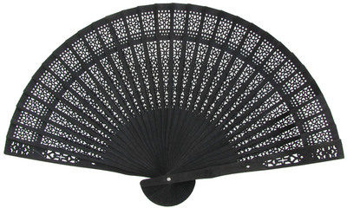 Hand-held fan 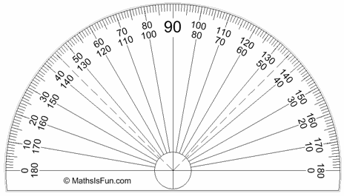 Protractor  - Show a protractor to illustrate that a half turn is measured as 180 degrees (denoted as 180⁰). Hence one complete rotation is measured as 360 degrees.  - Discuss the sizes of angles associated with quarter-turn (90⁰), half-turn (180⁰), three quarter-turn (270⁰), and complete turn (360⁰).  quarter-turn half-turn three quarter-turn complete turn  (90⁰) (180⁰) (270⁰) (360⁰).  - Use the proper symbols in naming angles, e.g., ∠ABC, ∠x and and for right angle.  - Review different types of angles: acute (less than 90⁰), right (90⁰), obtuse (more than 90⁰ but less than 180⁰) and reflex (more than 180⁰). Show relationship between an acute angle and its corresponding reflex angle (see diagram below).  - Emphasise that the naming of a reflex angle must be preceded with the word ‘reflex’ as shown in the diagram below.  ∠XYZ  Reflex ∠XYZ  X  Y  Z  - Explain the use of inner scale and the outer scale in reading an angle. Show how the protractor should be positioned so that accurate reading can be obtained.  - Guide students to use the protractor to measure ready angles in degrees and to draw angles of specified magnitudes. Give sufficient practice to ensure all students are able to read the size of any angle.  - Use the protractor or a corner of a rectangle (or the set-square) to determine if an angle is acute or obtuse. Use the straight edge to determine if an angle is a straight angle (180⁰), an obtuse or a reflex angle.  - Introduce the meaning of two angles being complementary to one another if their sum = 90⁰. Use this property to find the other complementary angle of a given angle.  - Similarly introduce the meaning of supplementary angles. Use this property to find the supplementary angle of a given angle.  - Show a line with several angles meeting at a point and with a sum of 180 degrees. Introduce the term ‘adjacent angles on a straight line’. Emphasise that a few angles which sum up 180⁰ will meet at a point on a straight line. Use this property to find unknown angles on a straight line.  - Guide students to draw two intersecting lines and identify the pairs of vertically opposite angles. Guide them to discover that vertically opposite angles are equal by measuring these angles with a protractor.  - Give further practice on problems related to the above properties of angles.  - Investigation:  Provide each group with a set of cut-outs of angles with preset sizes totaling 360⁰, e.g. (150⁰, 120⁰, 90⁰), (100⁰, 90⁰, 70⁰, 60⁰, 40⁰) [Please see the sample set shown below.]  Sample set: (100⁰, 90⁰, 70⁰, 60⁰, 40⁰)  100⁰ 90⁰ 70⁰ 60⁰ 40⁰  O  Instruct students to:  - measure and label the size of each angle  - paste the angles (with vertices pointing to a fixed point)  - take note that all the given angles meet at one point and,  - conclude that angles at a point sum up to 360⁰.  - Guide students to mark a point on a plain paper and draw a few lines radiating from this point to verify this property.  Measure all angles and then add them up to show that sum of angles at a point = 360⁰.  O  - Examples:  - In the figure AOD is a straight line and angle AOC is a right angle. Find  - angle BOC,  - angle AOE.  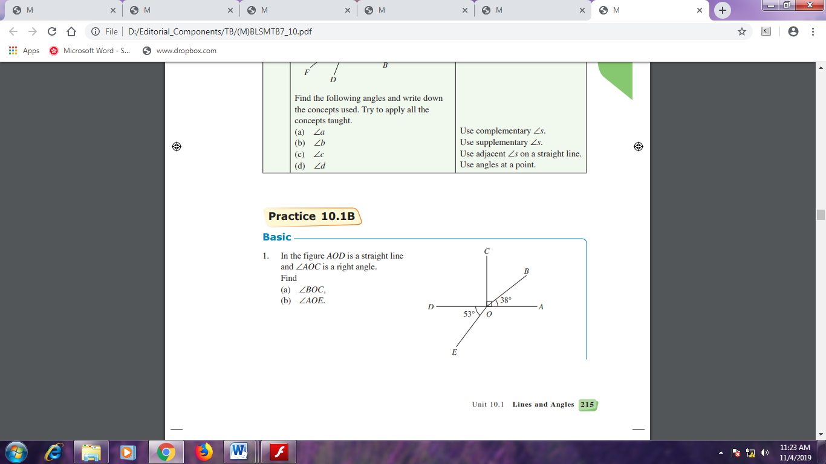  - In the figure, BOE and COF are straight lines, and angle AOB = angle BOC. Find a) angle EOF, b) angle AOF.  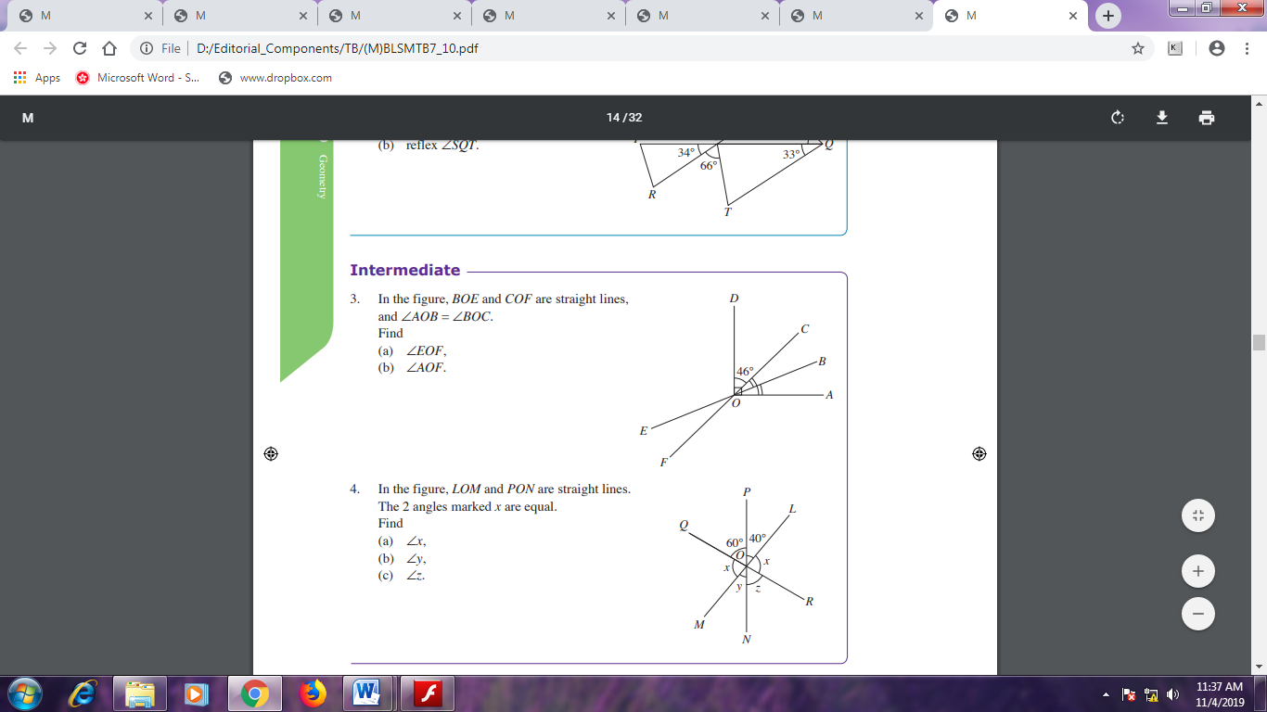  - Explain the types of triangles: scalene, right-angled, isosceles and equilateral triangles. Guide students to identify types of triangles:  - Oral quizzes:  - ‘I have 3 sides. I have two equal sides. What’s my name?’  - ‘I have 3 sides. All my 3 angles are equal. What am I?’  - Review that the sum of interior angles of a triangle and the angle property of exterior angles through a demonstration as follows:  - Construct a random triangle PQR on a plain paper. Extend the side along RP at corner P (Diagram 1).  - Duplicate the triangle PQR on a colour paper and cut up the three angles.(Diagram 2)  - Arrange and paste cutout angles Q and R next to the corner P so that the three angles are adjacent angles on a straight line. (Diagram 3)  This shows that:  - Sum of interior angles of a triangle = 180⁰, and  - Exterior angle = sum of interior opposite angles  P  Q  R  P  Q  R  P  Q  R  Diagram 1 Diagram 2 Diagram 3  - Apply these properties in finding unknown angles in triangles.  - Examples:  1) In the triangle ABC, X is a point on BC such that AB = AX.  Given that BAX = XAC = 40^{O}. CalculateACX.  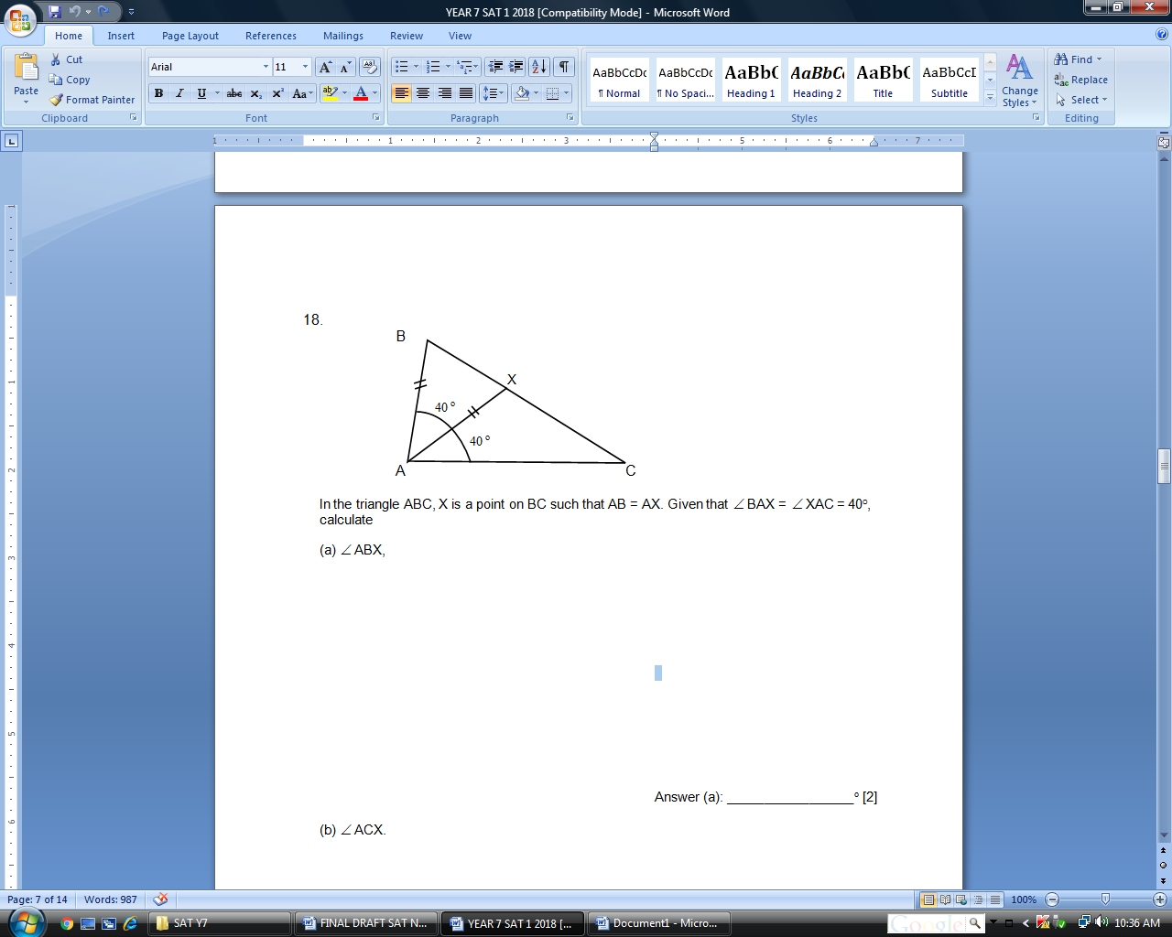  2) In the figure, AB = AC and ABE is a straight line. Find angle n  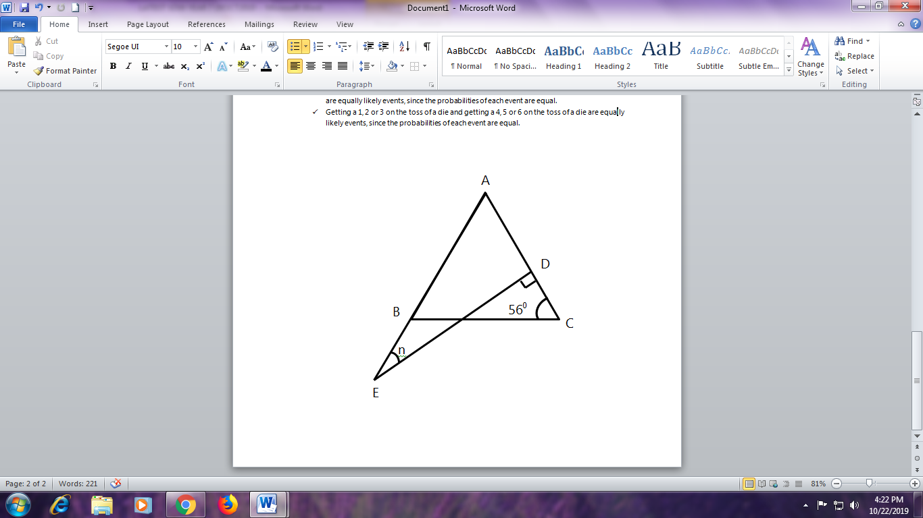  - Guide students to construct different types of triangles given:  - Two sides and the included angle (SAS)  - Two angles and the included side (ASA)  Examples:  - Construct triangle ABC where AB = 7 cm, AC = 6 cm and A = 40^{O}  - Length of BC = ________________ cm  - ACB = ___________________^{O}  - Construct triangle XYZ where XY = 6 cm, YZ = 7.5 cm and XYZ = 76^{O}  - Construct triangle DEF where DE = 5.5 cm, DF = 6 cm and D = 107^{O}  - Construct triangle DEF where DE = 7 cm, D = 59^{O} and E = 35^{O}  - Construct triangle KLM where KL = 5 cm, KLM = 33^{O} and LKM = 127^{O}

- DATA ANALYSIS & PROBABILITY ( WEEKS)
SUB-TOPICS | LEARNING OUTCOMES | LEARNING EXPERIENCE/EXEMPLIFICATION | INSTRUCTION TIME
3.1 DATA ANALYSIS | Students should be able to: |  | 3
- Types of data  - Pictograms, Bar charts, Pie charts, Frequency tables  - Line graphs  - Mode, Median, Mean & Range | - Understand and use the vocabulary to describe different types of data: quantitative; categorical (qualitative); discrete; ungrouped and grouped; continuous.  - Collect and organise data and construct:  - frequency tables for ungrouped and grouped discrete data.  - pictograms;  - bar charts for discrete data;  - pie charts for categorical data;  Read, analyse and interpret these diagrams and charts and draw simple conclusions from them.  - Read information in a line graph and understand the relationship between the two given variables (e.g. distance/time, conversion graphs).  *Related to 1.10.3 graphs of simple linear functions arising from real-life situations (Relationships & graphs)*  - Calculate the mode, median, mean and range for a set of data, including from an ungrouped frequency table.  Find the modal class for grouped discrete data.  - Compare two simple distributions using the range and one measure of average (mode, median or mean). | Quantitative data Qualitative data (categorical)  information about quantities; information that can be measured and written down with numbers. information about qualities; information that can't actually be measured.  The amount of money in your wallet. Your age. The age of your father’s car. The colour of the sky. The softness of the cat.  Type of data Discrete data Continuous data  meaning Has clear spaces between values. falls on a continuous sequence.  nature countable measurable  values Can take only distinct or separate values (counted in whole numbers or integers) Can take any value in some interval  Graphical representation Bar graph Histogram  Tabulation is known as Ungrouped frequency distribution Grouped frequency distribution  Classification Mutually inclusive Mutually exclusive  Examples Number of students in your classroom. The number of durians on its tree. Your mass. Your mass is not a specific fixed number. Time in a race. A race can be timed to a millisecond. It’s not set to a specific fixed number.  - Give examples of ‘data’ and invite students to give more examples of data. Examples of data: height, age, shoe size, weight, colour, volume, number of cars, favourite food items, duration, prices, etc.  - Discuss how some types of data can be collected by using various instruments such as ruler, weighing machine, stop-watch, etc. However, some data cannot be measured by any physical instruments but by direct observation or interviews (e.g. colour, favourite food).  - Discuss briefly the use of the various methods of data collection and examples of data that can be collected.  - Frequency Tables  Practical Activity:  Collect a few sets of real data (e.g., heights, age, colour, etc.) using tally sheets and guide students to prepare frequency tables.  - Interpret the frequency tables to find answers to the set of data.  Examples:  - Which is the most popular food item?  - How many more choose satay than choose laksa?  - Pictograms  - Show a ready-made pictogram to explain the important features of pictograms: uniform column width, uniform picture size, key to a picture, horizontal axis for data, vertical axis for implied frequency (by the number of pictures), title of pictogram, etc.  - Interpret the pictogram and find answers to questions related to the data.  Example:  The following pictograph shows how a group of students travelled to school one morning  Walking  Bus 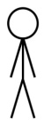  Bicycle   Car   Key:  represents 4 students  - How many students travelled to school by car?  - If the total number of students involved in the survey is 56, how many symbols must be drawn in the pictogram for the students walking to school?  - Guide students to construct a pictogram from a set of given data.  - Bar Charts  - Show a ready-made bar chart to explain the important features of bar charts: uniform column width, horizontal axis for data, vertical axis for frequency, title of bar chart, etc.  - Interpret the bar chart and find answers to questions related to the data.  Example:  The bar graph shows the number of storybooks read by students in a school.  Express the number of students who read only 3 storybooks as a fraction of the total number of students in the school. (Give your answer in its simplest form).  - Guide students to construct a bar chart from a set of given data.  - Group activity:  Carry out a group activity to investigate students’ favourite snack during the recess (or other preferences) on a particular day. The following steps are recommended.  - Describe the purpose of this survey and how it can be carried out.  - Instruct the groups to discuss among them and plan out their steps (role of each member, preparing an observation form, time of survey, etc.)  - Check the group plans and help students to improve their plans.  - Make arrangements to carry out the activity.  - The group constructs the frequency table.  - The group constructs a bar chart.  - The group explain and interpret bar charts to the class.  - Pie charts  - Examples:  - The pie chart shows the number of chiffon cakes of each flavour sold on a particular day. Copy and complete the corresponding table.  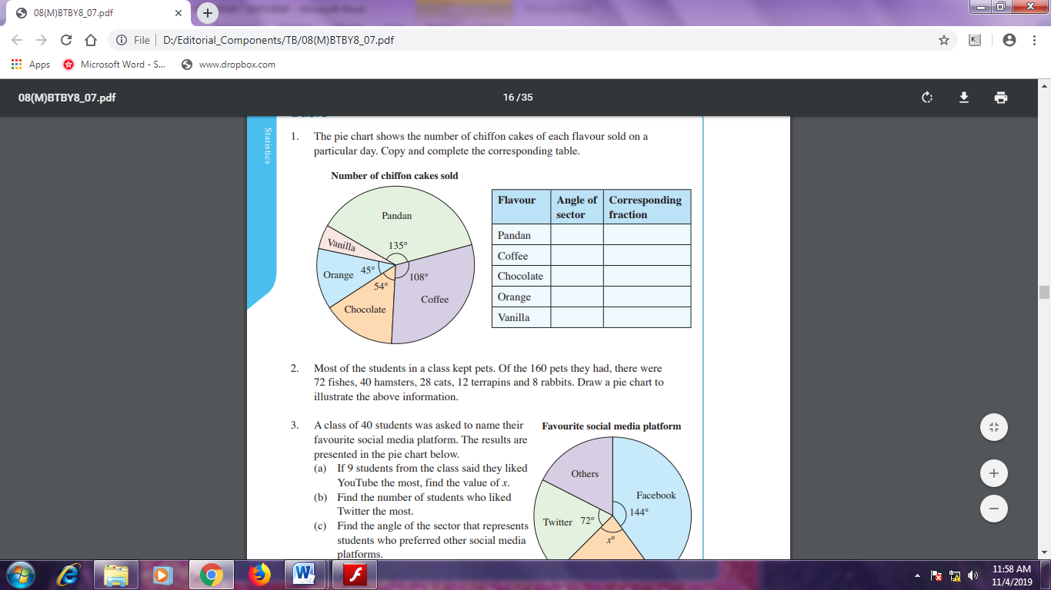  - Most of the students in a class kept pets. Of the 160 pets they had, there were 72 fishes, 40 hamsters, 28 cats, 12 terrapins and 8 rabbits. Draw a pie chart to illustrate the above information.  Solution: Angle of sector for each type of pet is needed to draw the pie chart.  Type of pet Frequency Angle of sector  Fish 72 $$\frac{72}{160}×360°=162°$$  Hamster 40 $$\frac{40}{160}×360°=90°$$  Cat 28 $$\frac{28}{160}×360°=63°$$  Terrapin 12 $$\frac{12}{160}×360°=27°$$  Rabbit 8 $$\frac{8}{160}×360°=18°$$  Refer to 2.1.4 and 2.3.2 to draw the pie chart.  - Show a pie chart with given sector angles and corresponding quantities. Guide students to interpret the pie chart. Use the idea of proportion to establish the relationship between the size of angle and the amount represented by a sector.  Example: The pie chart shows the amount of money shared among four siblings: Ashley (A), Bella (B), Camille (C) and Daniel (D).  Ashley received $60. The angle of the sector representing Ashley’s share is 150⁰.  150⁰  y⁰  120⁰  z⁰  Calculate (i) the total amount of money shared between the siblings, (ii) the amount of money received by Bella, (iii) the angle (y⁰) of the sector C, and (iv) the angle of the sector D and the amount of money received by Daniel.  Solution:  The angle of a sector is proportional to the amount represented by the sector.  - Let the total amount of money be T. It is represented by the whole circle with angle at centre = 360⁰.  For A, $60 is represented by a sector of 150⁰.  Therefore, .  Hence, T = 144. The total amount of money is $144.  - For B, the amount of money received, $x$ is represented by a sector of 120⁰.  Therefore, . [or alternatively, ]  Hence,$x$ = 48. The amount of money received by Bella is $48.  - For C, the amount of money received, $24 is represented by a sector of y⁰.  Therefore, . [or alternatively, ]  Hence, y = 60. The angle of the sector C is 60⁰.  - For D, the amount of money received, k is represented by a sector of z⁰.  k can be found by adding up the money received by the siblings,  k + 60 + 48 + 24 = 144  k = 12  Hence, Daniel received $12.  Also, z + 150 + 120 + 60 = 360.  Hence, z = 30. The angle of the sector D is 30⁰.  - Examples:  - A wildlife biologist made a study on the population growth of hippopotamus and recorded the information on a graph. Answer the questions based on the graph.  a) How many hippos were there in 2007?  - How many more hippos were recorded in the year 2008 than in 2006?  2) The graph below shows the monthly cost of a long-distance calling plan.  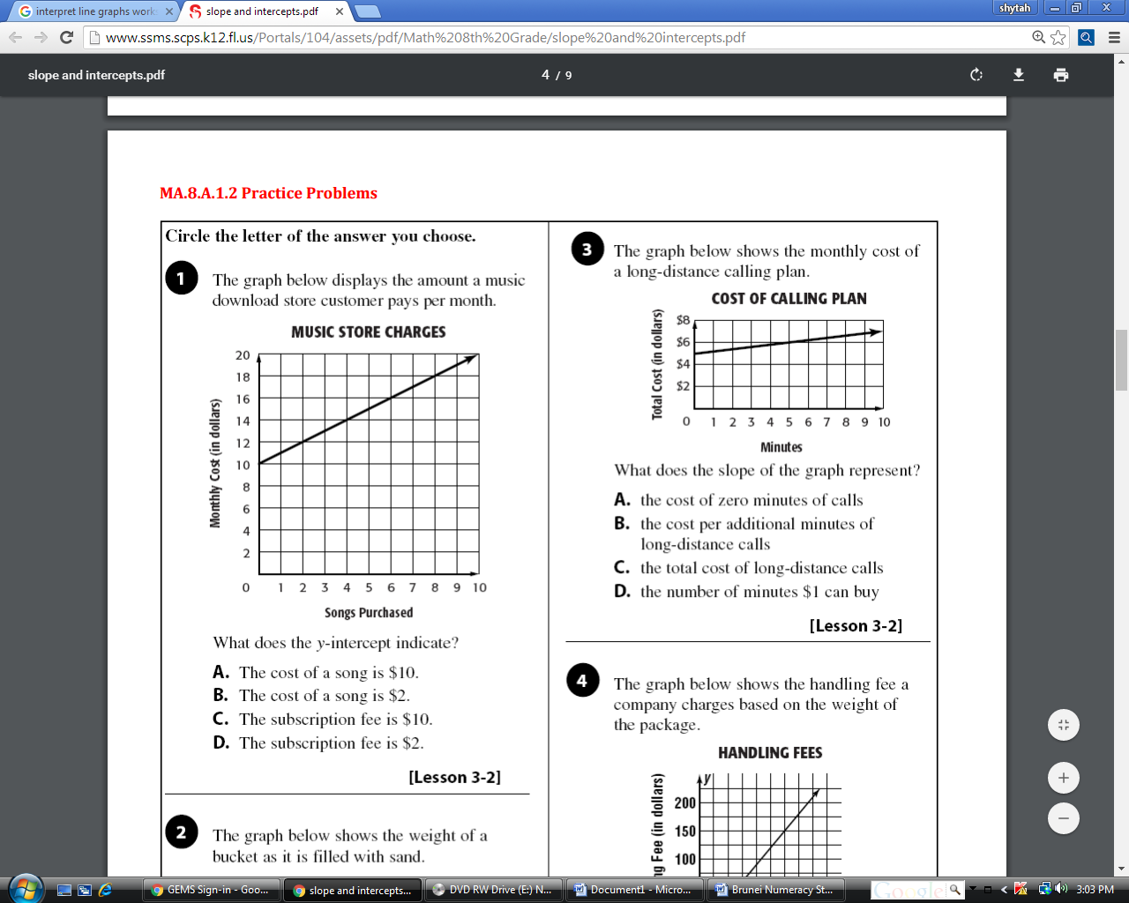  What does the slope of the graph represent?  - The cost of zero minutes of calls  - The cost per additional minutes of long-distance calls  - The total cost of long-distance calls  - The number of minutes $1 can buy  - Linda saw the following graph in a fitness magazine.  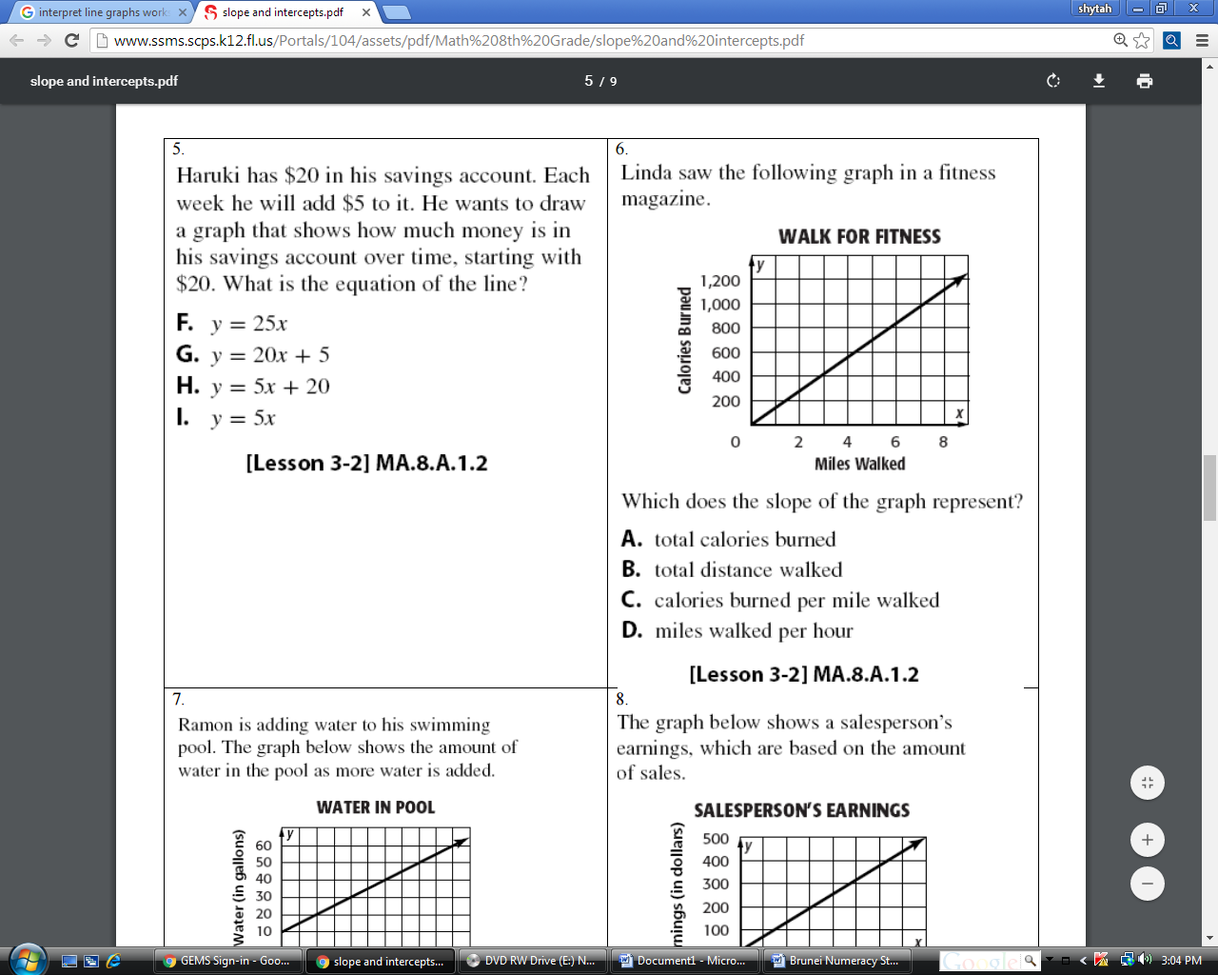  Which does the slope of the graph represent?  a) Total calories burned  - Total distance walked  - Calories burned per mile walked  - Miles walked per hour  - Mean  - Revise the concept of average of a set of values through examples. Explain that ‘average’ is a representative value of a given set of values through everyday examples: average weight, average income, etc.  - Introduce the term ‘mean’ to replace the term ‘average’.  - Compare data (e.g., boys’ heights verses girls’ heights) by comparing means from given sets of data.  - Guide students to apply the concept of mean to solve simple problems related to means.  - Examples:  - Calculate the mean of the set of values given in the frequency table.  X 0 1 2 3 4  f 3 4 2 5 1  - The mean of 5 numbers is 14. Four of the numbers are 20, 16, 11 and 10. Find the 5th number.  - The mean of 4 numbers is 31. The mean of another 8 numbers is 37. Calculate the mean of the 12 numbers.  - Mode  - Introduce the idea of mode as the most frequent value or measure (or occurrence) in a set of data. It is used as a representative value or measure (or occurrence) of the set data.  - Give examples of data which are not measured in terms of numbers, e.g., colour, race, gender, types of fuel, classes of tickets, etc. Show that such data can be analysed and a representative measure/occurrence can be identified.  - Explain the use of mode as a reference in making decisions, as shown in the following examples:  1) Identify the mode of the following set of sizes of shoes sold in a sale:  23, 24, 24, 25, 26, 26, 26, 26, 27, 29, 30, 32.  2) Find the modal value in the given frequency distributions.  Value, x 5 6 7 8 9  Frequency, f 31 40 22 13 8  3) The frequency distribution table given below shows the distribution of colours of T-shirts sold during a grand sale period. State the modal colour of the distribution.  Colour Green Yellow White Red Blue  Number sold (frequency) 45 36 38 71 28  - Median  - Introduce the idea of median as the middle value of a set of values arranged in order of size. Emphasise that if there are even number of values in a set, the median is the average of the two middle values.  - Discuss examples of medians being used as a representative value of a set of data, especially in sets of data where there are extremely high or low values.  - Compare the use of ‘mean’ and ‘median’ as representative of a given set of values.  Examples:  - Find the median of the set of values: 4, 0, 1, 2, 1, 3, 4, 1, 2, 0.  Rearranged in ascending order: 0, 0, 1, 1, 1, 2, 2, 3, 4, 4.  There are two values in the middle of the sequence.  Median $= \frac{1+2}{2}=1.5$  [Guide students to interpret the data and use a strategy to locate the position of the median, e.g. median position = ½ (n+1)^{th}.]  - Find the median and mean of the set of data:  23, 24, 24, 25, 26, 27, 29, 30, 32.  Median = middle value = 26  Mean = 26.67  [The values of median and mean are close by each other.]  3) Find the median and mean of the set of data: 23, 24, 24, 25, 26, 27, 29, 30, 98.  Median = middle value = 26  Mean = 34  [Median value ‘26’ is a better representative since most values lie between 23 and 30. ‘98’ is an extremely large and it has increased the size of the ‘mean’.]  - Find the median of the set of values given in the frequency table.  X 0 1 2 3 4  f 2 3 2 1 2  - Solve simple problems involving mean, mode and median.  - Range  - The range for a set of data is the highest value of the set minus the lowest value.  Range = highest value – lowest value  - The range is not an average. It shows the spread of the data.  It is used to compare two or more sets of similar data and also to comment on the consistency of two or more sets of data.  - Examples:  1) Rachel’s marks in 10 MCT tests were 4, 4, 7, 6, 6, 5, 7, 6, 9 and 6. Therefore, her mean mark is 60 ÷ 10 = 6 and the range is 9 – 4 = 5. Adil’s marks in the same tests were 6, 7, 6, 8, 5, 6, 5, 6, 5 and 6. Therefore, his mean mark is 60 ÷ 10 = 6 and the range is 8 – 5 = 3. Although the means are the same, Adil has a smaller range. This shows that Adil’s results are more consistent.  2) Find the range for each set of data:  - 3, 8, 7, 4, 5, 9, 10, 6, 7, 4.  b) 3.5, 4.2, 5.5, 3.7, 3.2, 4.8, 5.6, 3.9, 5.5, 3.8  - Ali took 7 science tests. His scores were:  68, 69, 69, 67, 65, 68, 67  What was the range of Ali’s test scores?  - Group Project:  Only the framework is suggested below. Teachers will provide more details and further instructions to their students so as to enable them to carry out the projects successfully.  Project Theme: Statistics in real life.  Group Size: 4-5 students.  Duration: 3 weeks  General Instruction:  Each group will be given a theme for investigation.  Suggested themes: “Favourite TV programmes”, “My favourite subjects-Boys verses Girls”, “How students spend the recess time”, etc.  They will follow three stages in their investigation:  1) Planning  - What data will be required in the investigation?  - What is the most suitable method(s) for data collection?  - Design the survey questionnaire or interview guide.  - What statistical representation will be used? (bar charts, pie charts, histograms, mean, etc.)  - Data collection and processing  - Carry out data collection.  - Analyse the data.  - Prepare statistical representation.  - Report and presentation  - Provide support to each group in terms of materials.  - Examples:  - In a golf tournament, the club chairperson had to choose either Maria or Fay to play in the first round. In the previous eight rounds, their scores were as follows:  Maria’s scores: 75, 92, 80, 73, 72, 88, 86, 90  Fay’s scores: 80, 87, 85, 76, 85, 79, 84, 88  a) Calculate the mean score for each golfer.  - Find the range for each golfer.  - Which golfer would you choose to play in the tournament? Explain why.  - Dan has a choice of two buses to get to school: Number 50 or Number 63. Over a month, he kept a record of the number of minutes each bus was late when it set off from his home bus stop.  Bus No. 50: 4, 2, 0, 6, 4, 8, 8, 6, 3, 9  Bus No. 63: 3, 4, 0, 10, 3, 5, 13, 1, 0, 1  - For each bus, calculate the mean number of minutes late.  - Find the range for each bus.  - Which bus would you advise Dan to catch? Give a reason for your answer.

SUB-TOPICS | LEARNING OUTCOMES | LEARNING EXPERIENCE/EXEMPLIFICATION | INSTRUCTION TIME
3.2 PROBABILITY | Students should be able to: |  | 2
- Introduction to Probability  - Probability scale  - Mutually exclusive outcomes  - Theoretical probability & Experimental probability | - Recognise real-life examples of probability.  Understand the concept of probability and use the vocabulary of probability when describing events: certain, more likely, equally likely, less likely, or impossible.  - Understand and use the probability scale: a certain outcome is 1 or 100%, an impossible outcome is 0 or 0%, and an equally likely outcome is 0.5, ¹/₂ or 50%.  - Identify all the possible mutually exclusive outcomes of a single event.  - Understand that the theoretical probability of a single event is the ratio of the number of favourable outcomes to the total number of possible outcomes where all outcomes are equally likely.  Identify and justify probabilities of a single event based on equally likely outcomes in simple contexts.  - Understand that the experimental probability of a single event is the ratio of the number of favourable outcomes to the total number trials.  - Understand the difference between theoretical and experimental probabilities and compare in simple contexts.  - Estimate probabilities based on data collected from simple experiments.  Make and justify predictions about the population size when given a probability and experimental data in simple contexts.  (Related to ratios) | Probability is the chance or possibility that an event (something) will happen.  Event  Certain : will definitely happen. The Sun will rise and set every day. People will breathe air.  Impossible : will not happen. growing wings, going to the Sun, or breathing underwater  possible : could happen. may or may not actually happen visiting another country or getting a new pet.  Likely: will probably happen. read from a book next week.  Unlikely : will probably not happen. Not impossible. getting a pet tiger. Some people do have pet tigers, but it is uncommon.  More likely It is more likely that they will eat at break time than do their homework.  Less likely It is less likely that they will leave school early to go to Jerudong Park.  Equally likely it is equally likely for a coin to land on heads or tails  Activity 1:  - Introduce Probability and the words: always, sometimes, never.  Probability means how likely it is that something will happen.  We are learning to say or write a sentence with Probability words.  - I can make a sentence with always, sometimes, never, possible, impossible, certain, likely or unlikely.  Example:  Things we see or do in SCHOOL  always sometimes never  Have a break period Go to the library Bring a pet  See a teacher See a cat See a dolphin  - Introduce the words “possible” and “impossible”.  - Sorting possible and impossible sentences on a chart. Teacher gives the sentences.  Example:  - Rain today  - Flying cat  - Eat at Jolibee  - I grow purple hair  possible impossible  Then, students write their own sentences.  - Certain, likely, unlikely, impossible.  Sorting on chart (do in separate days). Teacher gives examples. Then students write their own sentences.  Day 1  likely unlikely  We have dinner tonight at home We have dinner tonight on a cruise ship  Day 2  certain impossible  Raining and thunderstorm Raining gumball  - Gumball machine:  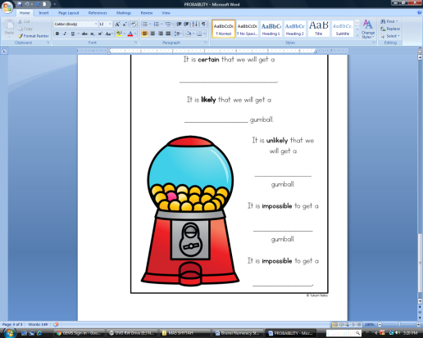  Look at the gumball machine and fill in the blanks:  - It is certain that we will get a ________________.  - It is likely that we will get a ____________ gumball.  - It is unlikely that we will get a ____________ gumball.  - It is impossible to get a ___________ gumball.  - It is impossible to get a ___________.  Provide a new worksheet (gumball machine without colour) and ask the students to colour their own gumballs. Then, answer the questions.  Activity 2:  Show a clear bag of two different colours of counters, such as blue and red connecting cubes.  Make sure there are more blue cubes than red. If they chose one cube from the bag, what colour would it be?  Since there are more blue cubes than red, it is more likely they would pick a blue cube.  It is less likely they would pick a red cube.  Repeat the activity again except have equal numbers of red and blue cubes. Since there are equal numbers of red and blue cubes, it is equally likely to pick a red or a blue cube.  Impossible Equally likely Certain  0 0% $$\frac{1}{2}$$ 50% 0.5 1 100%  - Equally likely events are events that have the same theoretical probability (or likelihood) of occurring.  - Mutually exclusive: cannot happen at the same time. It is impossible for them to happen together.  - The probability of both events happening together is ZERO.  Examples:  - Turning right and left  - Tossing a coin : heads and tails at the same time  - Today is Monday. Today is also Tuesday.  Activity 1  - Could the two events A and B in the following situations happen at the same time?  YES / NO  - Event A: roll a dice and get a “1”.  Event B: roll a dice and get a “6”.  - Event A: toss a coin and get “heads”.  Event B: toss a coin and get “tails”  - A bag contains 2 yellow balls and 3 blue balls. A ball is drawn from it.  Event A: You get a yellow ball.  Event B: You get a blue ball.  - Event A: roll a dice and get a “2”.  Event B: roll a dice and get an even number.  - One student is selected as the class monitor.  Event A: Jamal is selected as the monitor.  Event B: Peter is selected as the monitor.  In everyday life, there are events that cannot happen at the same time. We called these Mutually Exclusive Events.  - Can you write down two mutually exclusive events?  - Since mutually exclusive events cannot happen together, the probability that both events will happen together is equal to _____________.  - How about the probability that either one event will happen?  Activity 2  Complete the following.  - Roll a dice:  Event A: Roll a dice and get a “1”.  Event B: Roll a dice, and get a “4”.  The probability that you get a “1”, P(A), is ___________________.  The probability that you get a “4” , P(B) , is ___________________.  The probability of getting a “1” or a “4”, P(A or B), is _______________.  - Draw a coloured ball from the bag.  There are five balls of different colours (orange, yellow, red, blue and white) inside a bag.  Event A: Draw a white ball.  Event B: Draw an orange ball.  P(A) = ___________________.  P(B) = ___________________.  The probability of getting a white or an orange ball, P(A or B), is ________.  Discussion:  In the above cases, events A and B are _____________________________. State the relationship between P(A), P(B) and P(A or B).  P (A or B) = ____________ + ____________.  Why?  Examples:  - Year 7G is looking for a new form captain. The probability of Zara being a form captain is 0.2 while the probability of Aiman being a form captain is 0.4. What is the probability of either Zara or Aiman becoming a form captain?  - A bag contains 3 yellow balls, 2 green balls, 5 red balls and 6 black balls. What is the probability of either a yellow ball or a red ball being drawn if only one ball is drawn?  - The theoretical probability is what you expect to happen, but it isn't always what actually happens.  Examples:  - What is the probability of a coin landing on tails?  P(getting a tail) = $\frac{1}{2}$ or 50%.  You would probably answer that the chance is ½ or 50%.  - Imagine that you toss a coin 10 times. How many times would you expect it to land on tails?  You would expect it to land on tails 5 times.  P(getting a tail) = $\frac{5}{10}= \frac{1}{2}$ or 50%  You might say, 50% of the time, or half of the 10 times.  - What is the probability of getting a 2 when you toss a die?  There are 6 faces on a die (1, 2, 3, 4, 5 & 6).  P(getting a 2) = $\frac{1}{6}$ or 17%  - In the roll of a die, what is the probability of getting a prime number?  Out of the 6 possible outcomes, 2, 3 and 5 are prime numbers.  P(getting a prime) = $\frac{3}{6}= \frac{1}{2}$ or 50%.  - From a group of 20 players, a keeper is chosen. If 5 of the players are keepers, what is the probability that the player chosen will be a keeper?  P(keeper chosen) $= \frac{5}{20}= \frac{1}{4}$ or 25%  - Experimental probability refers to the probability of an event occurring when an experiment was conducted.  - Experimental probability is the ratio of the number of favourable outcomes to the total number trials.  The table below shows the results after Aini tossed the coin 10 times.  Outcomes Frequency  Heads 3  Tails 7  Total 10  The table shows the experimental probability. It is the probability obtained from the result of an experiment. It is what actually happens instead of what was expected to obtain.  Experimental probability of obtaining tails is $\frac{7}{10}= \frac{70}{100}=70\%$  Now, Aini continues to toss the same coin for 50 total tosses. The results are shown below.  Outcomes Frequency  Heads 27  Tails 23  Total 50  Now, the experimental probability of obtaining tails is $\frac{23}{50}= \frac{46}{100}=46\%$  The probability is still a bit higher than expected, but as more experiments were conducted; the experimental probability became closer to the theoretical probability (i.e. 50%).  - Compare theoretical and experimental probabilities using tossing a fair coin examples above to understand the difference between both probabilities.  Examples:  - The probability of students bringing calculators during a Mathematics exam is higher than normal school days.  - The probability of people staying indoor on a rainy day is greater than the probability of people going out.  - In a lucky draw event where for every purchase of $100 you will entitle one lucky draw cupon. The more lucky draw cupons you get the higher the chances you will get a prize in the lucky draw.  - The probability of full attendance girls in a class is $\frac{1}{2}$ . This means that the number of girls in the class is equal to the number of boys.  - The probability of full attendance girls in a class is $\frac{3}{10}$. This means that the number of girls in the class is less than the number of boys. In other words, 30% of the students in the class are girls, that is 70% of them are boys.  - The probability of full attendance girls in a class is $\frac{3}{4}$ . There are 15 girls in the class. How many students are there altogether?  Girls = $\frac{3}{4} ×total students=15$  Therefore, total students = 20 students.

